

USER INTERFACE DESIGN
23CSE25226
LAB MANUAL
Submitted by
Name | P. Vishal Sri Chandra Varma
Roll no | AV.SC.U4CSE25226
Year/Sem/Section | 1st Year/Sem-2/CSE-C
Credits | 03

Submitted to | DR. Raj Kumar Batchu
Designation | ASST.Proffessor (SL.Grade)
Department | School of computing

INDEX
S.NO | TITLE | PAGE NO: | REMARKS
1 | Week 1.:A.installation of vs code  B.Understanding basics of HTML  C.Understanding basics of HTML tags | 4-9
2 | Week 2.:A. desing a basic web page with headings ,paragraph,  table, by adding styles | 10-12
3 | Week 3.:A.Create class timetable using html elements  B.Create a html web page that should display syllabus of  all the subjects as an image format and also, the  timetable | 13-24
4 | Week 4.:A.Design a registration form using only HTML tags (no  CSS) with proper labels, table alignment, background  color, and borders.  B.Two forms displayed side by side using iframes .one is  login and another registration | 24-31
5 | Week 5.:A.creating a card layout using <div> tag consider  three cards and a button using html and css  B.navigation using iframe (mini website) upon clicking  each buttons the details about that button should be  display on the same page  C.Design amrita login page by showing different  campus on home page.upon clicking on each campus  the details about each campus should be display on  the same page use html and css to design a stylish  webpage | 32-48
6 | Week 6:A. : Design a responsive e-commerce application using  the grid layout. This application should contain  different categories of products such as electronics,  clothing, home-appliances, books.  B: Design a responsive e-commerce application using  the grid layout. This application should contain  different categories of products such as electronics,  clothing, home-appliances, books. Based on the  category we select corresponding products should be  displayed on the sidebar. | 49-63
7 | Week 7:A.:create a GitHub account and create a repository in it  and push all the week 6 code files in it. | 64-66
8 | Week 8:A.:create a web page that displays a square that  continuously rotates 360 using css animation  B.:create a ball that moves up and down continuously  using css animation  C.:create a circle that moves horizontally and rotates  At the same time | 67-72
9 | Week 9:Create a webpage using html,css,js based on the give  conditions:  A:create a button for each program , based on the button  clicked the corresponding program has to be executed and  should didplay the output  B:the logics for each button includes finding an even or odd  number , prime or not , factorial of a number , Armstrong or not  C:use appropriate design to display the output | 73-77
10 | Week 10:A:write JavaScript conditional statement to find the sign  of product of three numbers using functions .Display  an alert box with specified sign  B:write a java script conditional statements to sort 3  numbers using functions display an alert box to show  the result  C:write a java script conditional statement to find largest of  find largest of five numbers using function and onclick  event .display an alert box to show the result  D:write a java script for loop that will iterate from 0 to 15.  For each iteration ,it will check if the current number  odd or even , and display a message on screen  E:write a java script program to read 6 subjects marks from  the student then computes the average marks of students  then , this average is used to determine the corresponding  grade. | 78-83
11 | Week 11:A. A website requires users to enter a username. The  system should display a message while typing if the  username is less than 5 characters.  B. A registration form should validate email format before  submission. If invalid, the form should not be submitted.  C. A system should check password strength while typing  and display whether it is weak or strong.  D. A form should validate a mobile number when the user  leaves the input field. The number must be exactly 10  digits.  E. Design an HTML page, such that the registration form  must validate:  Name (not empty)  Email (valid format)  Password (minimum 6 characters) | 83-93
12 | Week-12 : To show the steps involved in installing and  using electron. | 93-87

WEEK – 1
1.A)AIM : steps to install vs code.
Procedure:
Step 1 :
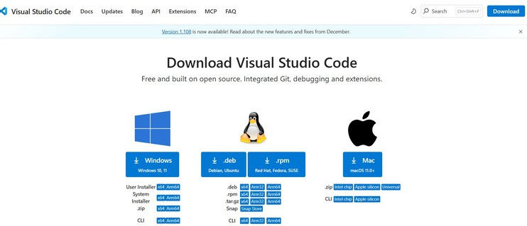
Step 2 :
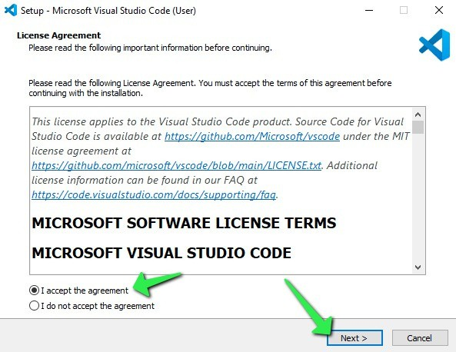
Step 3 :
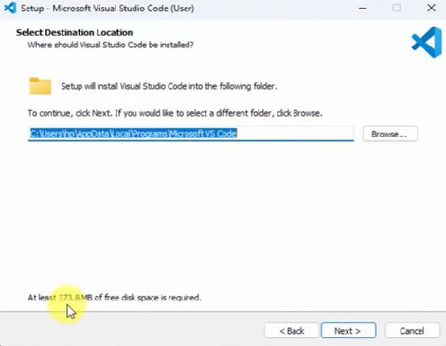
Step 4 :
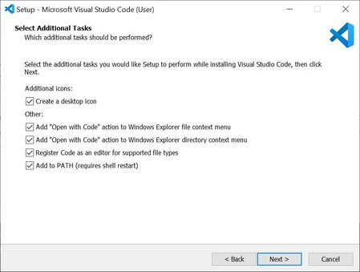
Step 5 :
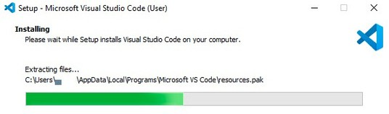
Step 6 :
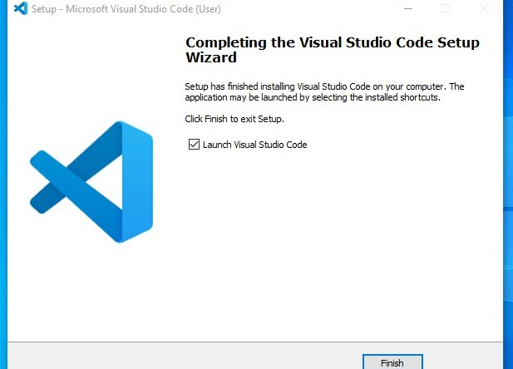
Step 7 :
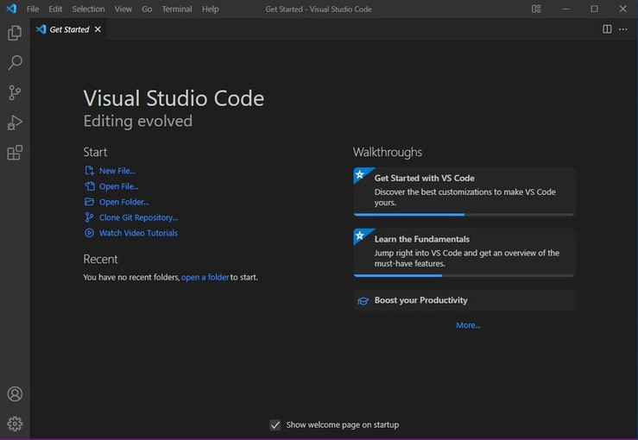

1.B) AIM : To learn the basics of HTML (basics.html)
Program :
UID25226-vishal
<!DOCTYPE html>
<html>
<head>
<title>first web page</title>
</head>
<body>
<h1>happy to learn html</h1>
<p >This is my first sample code</p>
</body>
</html>
Output :
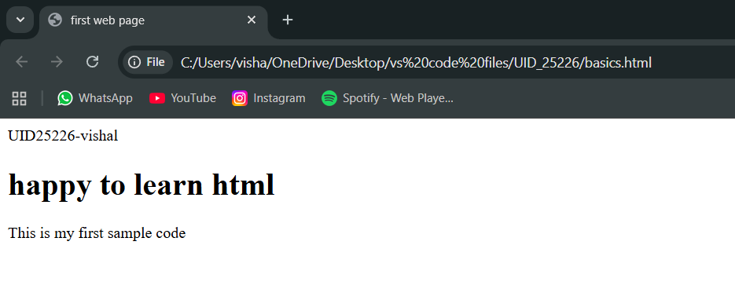

Explanation of the html tags :
. Abbreviation of HTML is hyper text markup language
. HTML is used to create and structure web pages
. HTML acts as skeleton for the web pages
. It tells the web browser what to display and how to display it
. <DOCTYPE html> : the <!DOCTYPE html> element tells the web browser that this an HTML document
or this is the latest version of HTML
. <html> : the <html> element is the root element of an HTML web page
. <head> : the <head> element will contain meta data about the HTML web page
. <title> : the <title> element specifies a title for the HTML Page
. <body> : the <body> element contains all visible content all visible content like text , image , links ,
tables , etc
. <h1> : the <h1> element defines a large heading
. <p> : the <p> element defines a paragraph
. <br> : the <br> element defines a line break. It is an empty tag with no end tag
. style : the HTML style attribute is used a add style to an element such as colour , font , size and more
. <img> : the <img> tag is a fundamental HTML element used to embed an image into web page
. <a> :the HTML <a> element stands for “anchor”, is used to define hyper link
. href : the HTML href attribute is used to add link to the html web page

1.C ) AIM : understanding basic HTML tags
Tags : <p>,<h1>,<img>,<a href>,<br>,<color>, Style and etc...,
Program:
UID-AV.SC.U4CSE25226
<!DOCTYPE html>
<html>
<head>
<title>links</title>
</head>
<body>
<h1 style=”color: pink; text-align: center;”
title=”amravathi”>amrita university</h1>
<p style=”color: red;”>amrita university is one of the top
university in india<br>one of the best in ap also<br><a
href=”https://www.amrita.edu”>click here to learn about
amrita</a> </p>
<img src=”https://images.seeklogo.com/logo-png/51/2/amrita-
ransl-vidyapeetham-logo-png_seeklogo-519922.png”
alt=”Amrita University” width=”500” height=”300”>
<h2 sytle=”color: brown; text-align: center;”
title=”amravathi”>vit university</h2>
<p style=”color: aqua;”>vit is one of the good
university<br>one of the best in ap also<br><a
href=”https://vit.ac.in/”>click here to know about
vit</a></p>
<img

src=”https://i.pinimg.com/474x/a7/e2/da/a7e2da54368b7a0a0f53fd
40065053c0.jpg” alt=”VIT University” width=”500”
height=”300”>
<h3 style=”color: greenyellow; text-align: center;”
title=”amravathi”>srm university</h3>
<p style=”color: blueviolet;”>srm in one of the best
ranslate in india<br>one of the best in ap also<br><a
href=”https://www.srmist.edu.in/”>click here about
srm</a></p>
<img src=”https://images.seeklogo.com/logo-png/38/1/srm-
institute-of-science-and-technology-logo-png_seeklogo-
381994.png” alt=”SRM University” width=”500”
height=”300”>
</body>
</html>
Output:
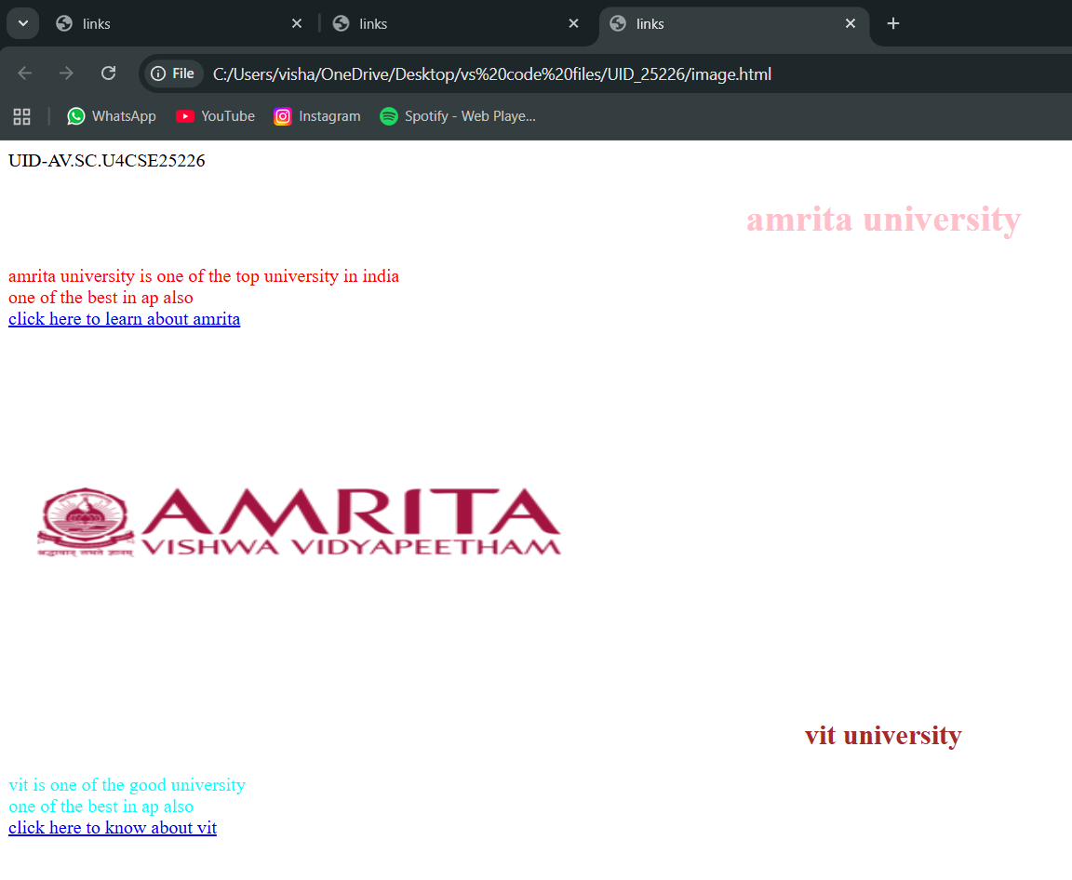
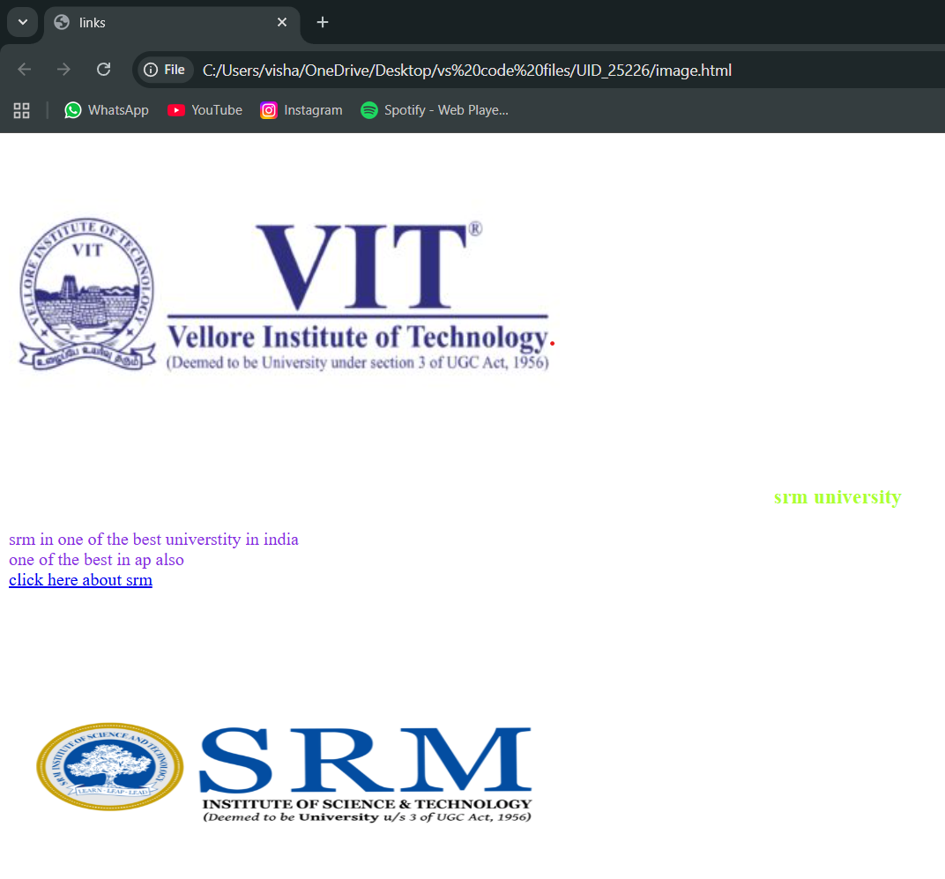
Explanation of the code:
. <head> : the <head> element will contain meta data about the HTML web page
. <title> : the <title> element specifies a title for the HTML Page
. <body> : the <body> element contains all visible content all visible content like text ,
image , links , tables , etc
. <h1> : the <h1> element defines a large heading
. <p> : the <p> element defines a paragraph
. <br> : the <br> element defines a line break. It is an empty tag with no end tag
. style : the HTML style attribute is used a add style to an element such as colour , font ,
size and more
. <img> : the <img> tag is a fundamental HTML element used to embed an image into
web page
. <a> :the HTML <a> element stands for “anchor”, is used to define hyper link
. href : the HTML href attribute is used to add link to the html web page

Week – 2:
2.A)Aim : desing a basic web page with headings ,paragraph,table, by adding styles
Program:
AV.SC.U4CSE25226-UID
<!DOCTYPE html>
<html>
<head>
<title>VISHAL web page</title>
</head>
<body style=”background-color: black;background-image:
url(https://drupal.mbauniverse.com/sites/default/files/collegebanner/Amravati-02.jpg);background-repeat: no-repeat;background-size: cover;”>
<h1 style=”text-align: center;color: ghostwhite;border: 3px solid black;”>Amrita Vishwa Vidyapeetham</h1>
<pre style=”text-align: center;color: burlywood;font-family: Georgia, ‘Times New Roman’, Times, serif;font-style: italic;font-size: large;”>
Amrita Vishwa Vidyapeetham, Amaravati is a premier, NAAC A++ accredited multi-disciplinary campus located in Andhra Pradesh’s capital region.

It offers research-intensive undergraduate and postgraduate programs, focusing on engineering, data science, and management.

The 200-acre lush green campus emphasizes sustainability and modern infrastructure, including advanced laboratories.
</pre>
<table border=”2” align=”center” bgcolor=”lightgray” style=”text-align: center;”>
<caption style=”font-size: x-large;font-weight: bold;color: black; background-color: gray;”>All Amrita campus Details</caption>
<tr style=”color: red;font-style: bold;font-size: large;”>
<th>S.No</th>
<th>Campus Name</th>
<th>location</th>
<th>Department</th>
<th>faculty name</th>
<th>Contact No,E mail</th>
</tr>
<tr style=”color: rgb(10, 10, 10);font-style: italic;font-size: medium;”>
<td>1.</td>
<td>AMRAVTHI</td>
<td>ranslate</td>
<td>UID-CSE</td>
<td>DR.Raj kumar batchu</td>
<td>94949 99944</td>
</tr>
<tr style=”color: rgb(10, 10, 10);font-style: italic;font-size: medium;”>
<td>2.</td>
<td>Amrithapuri</td>
<td>amritapuri</td>
<td>UID-CSE</td>
<td>DR.Ajay kumar</td>
<td>84848 44888</td>
</tr>
<tr style=”color: rgb(10, 10, 10);font-style: italic;font-size: medium;”>
<td>3.</td>
<td>Chennai</td>
<td>ransla</td>
<td>UID-CSE</td>
<td>DR.Suresh babu</td>
<td>96969 99969</td>
</tr>
</table>
<button url=”https://www.amrita.edu/campus/amaravati/” style=”display: block;margin: auto;margin-top: 20px;padding: 10px 20px;font-size: large;background-color: lightgray;color: black;border: 2px solid black;border-radius: 5px;cursor: pointer;” onclick=”alert(‘Welcome to Amrita Vishwa Vidyapeetham!’)”>for more about amrita</button>
</body>
</html>

Output :
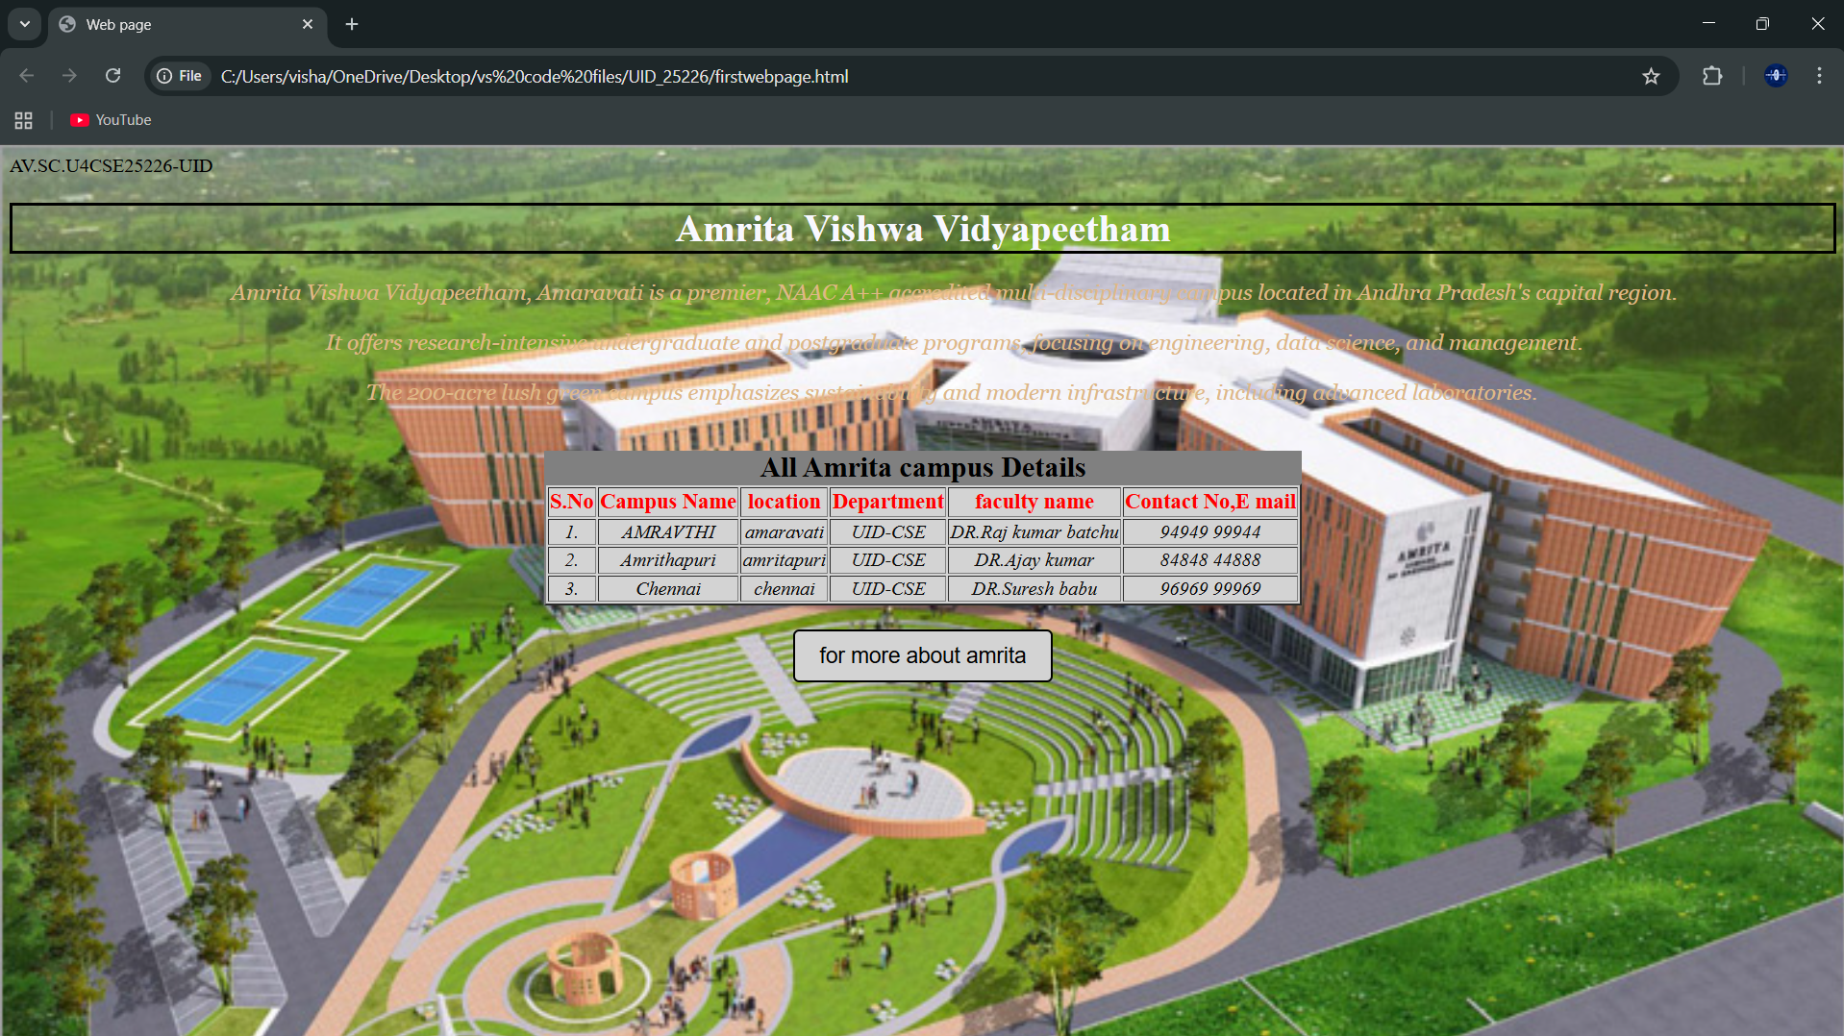
Explanation :
. <DOCTYPE html> : the <!DOCTYPE html> element tells the web browser that this an HTML document
or this is the latest version of HTML
. <html> : the <html> element is the root element of an HTML web page
. <head> : the <head> element will contain meta data about the HTML web page
. <title> : the <title> element specifies a title for the HTML Page
. <body> : the <body> element contains all visible content all visible content like text , image , links ,
tables , etc
. <table>: the element <table> is used to create a table
. <tr>: the element <tr> creates a new row in the table
. <th>: the element <th> create a new heading inside the table
. <td>: the element <td> fill the columns in the row
. <button>: the element <button> is used for button .
The style attribute is used to add style the elements in the html webpage and url attribute for adding the url or link to the button

Week-3
3.A)Aim : to create a time table using html by using tags like
<table>,<td>,<th>,<tr>,and using style attribute in it
Program :
UID-AV.SC.U4CSE25226
<!DOCTYPE html>
<html>
<head>
<title>CSE Timetable</title>
</head>
<body style=”font-family: Arial; margin:20px;”>
<h2 style=”text-align:center;”>Master Time Table</h2>
<h3 style=”text-align:center;”>CSE II Semester – C Section</h3>
<table border=”1” width=”100%” cellpadding=”6” cellspacing=”0”>
<tr>
<td><b>Dept:</b> CSE</td>
<td><b>Class:</b> B.Tech CSE-C</td>
<td><b>Semester:</b> II</td>
<td><b>Room:</b> 512</td>
</tr>
<tr>
<td colspan=”2”>
<b>Class Advisor 1:</b> Mr. Budati Jaya Lakshminarayana<br>
bj_lakshminarayana@amrita.edu<br>
+91-7989795768
</td>
<td colspan=”2”>
<b>Class Advisor 2:</b> Dr. Arun Kumar S<br>
s_arunkumar@av.amrita.edu<br>
+91-9840857202
</td>
</tr>
</table>
<br>
<table border=”1” width=”100%” cellpadding=”6” cellspacing=”0” style=”text-align:center;”>
<tr>
<th rowspan=”2”>Time/Day</th>
<th>08:55-09:45</th>
<th>09:45-10:35</th>
<th style=”background:yellow; writing-mode: sideways-lr;” rowspan=”7”>Break</th>
<th>10:45-11:35</th>
<th>11:35-12:25</th>
<th>12:25-01:15</th>
<th style=”background:yellow; writing-mode: sideways-lr;” rowspan=”7”>Lunch</th>
<th>02:10-03:00</th>
<th style=”background:yellow; writing-mode: sideways-lr;” rowspan=”7”>Break</th>
<th>03:10-04:00</th>
<th>04:00-04:50</th>
</tr>
<tr>
<th>slot1</th>
<th>slot2</th>
<th>slot3</th>
<th>slot4</th>
<th>slot5</th>
<th>slot6</th>
<th>slot7</th>
<th>slot8</th>
</tr>
<tr>
<th>Monday</th>
<td colspan=”2”>23MAT116 Discrete Mathematics Lab</td>
<td>23PHY115 Modern Physics</td>
<td>23CSE111 OOP</td>
<td>22ADM111 GGI</td>
<td >GGI (P)</td>
<td colspan=”2”>Library / Sports</td>
</tr>
<tr>
<th>Tuesday</th>
<td colspan=”2”>23CSE113 UI Design Lab</td>
<td>Linear Algebra</td>
<td>Discrete Mathematics</td>
<td style=”color:red;”><b>COUNSELLING</b></td>
<td>Manufacturing Practice Lab</td>
<td colspan=”2”>Manufacturing Practice Lab</td>
</tr>
<tr>
<th>Wednesday</th>
<td>Modern Physics</td>
<td>UI Design</td>
<td colspan=”2”>Linear Algebra Lab</td>
<td style=”color:red;”><b>COUNSELLING</b></td>
<td >Library</td>
<td>GGI</td>
<td>Library / Sports</td>
</tr>
<tr>
<th>Thursday</th>
<td>OOP</td>
<td>Discrete Mathematics</td>
<td colspan=”2”>OOP Lab</td>
<td>Linear Algebra</td>
<td >Library</td>
<td colspan=”2”>Library / Sports</td>
</tr>
<tr>
<th>Friday</th>
<td>OOP</td>
<td>Discrete Mathematics</td>
<td>Modern Physics</td>
<td>UI Design</td>
<td>Linear Algebra</td>
<td >Library</td>
<td colspan=”2”>Library / Sports</td>
</tr>
</table>
<br>
<table border=”1” width=”100%” cellpadding=”6” cellspacing=”0”>
<tr>
<th>Course code</th>
<th>Course Name</th>
<th>Faculty name</th>
<th>L-T-P</th>
<th>Credits</th>
</tr>
<tr>
<td>23MAT116</td>
<td>Discrete Mathematics</td>
<td>Dr.bixapathi</td>
<td>3-0-0</td>
<td>3</td>
</tr>
<tr>
<td>23PHY115</td>
<td>Modern Physics</td>
<td>Dr.sowmya</td>
<td>3-0-0</td>
<td>3</td>
</tr>
<tr>
<td>23CSE111</td>
<td>OOP</td>
<td>Dr.satya ranslat singh</td>
<td>3-0-0</td>
<td>3</td>
</tr>
<tr>
<td>22ADM111</td>
<td>GGI</td>
<td>DR.siva panuganti</td>
<td>2-0-0</td>
<td>2</td>
</tr>
<tr>
<td>23CSE113</td>
<td>UI Design</td>
<td>Dr.rajshekar batchu</td>
<td>3-0-0</td>
<td>3</td>
</tr>
<tr>
<td>23MEE115</td>
<td>Manufacturing Practice</td>
<td>Dr.sathies</td>
<td>0-0-3</td>
<td>1</td>
</tr>
<tr>
<td>23MAT116</td>
<td>Discrete Mathematics Lab</td>
<td>Dr.Thota ranslat rao</td>
<td>0-0-2</td>
<td>1</td>
</tr>
</table>
</body>
</html>
Output :
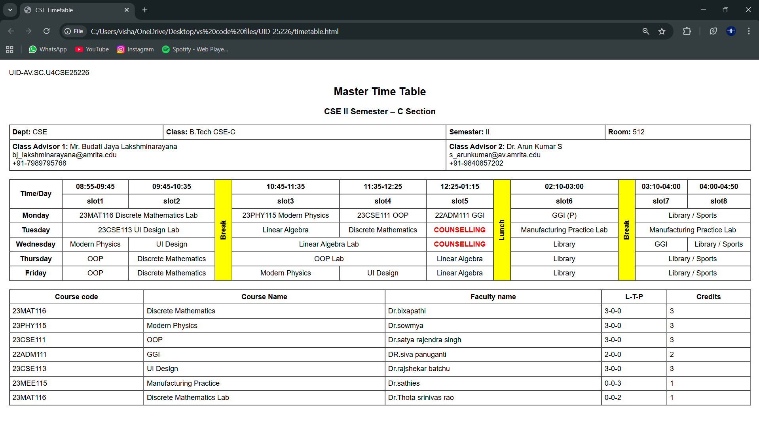
Explanation :
<DOCTYPE html> : the <!DOCTYPE html> element tells the web browser that this an HTML document
or this is the latest version of HTML
<html> : the <html> element is the root element of an HTML web page
<head> : the <head> element will contain meta data about the HTML web page
<title> : the <title> element specifies a title for the HTML Page
<body> : the <body> element contains all visible content all visible content like text , image , links ,
tables , etc
we use this tags in addition to the above tags that we used in other programs
<h> : we used <h> element for heading
<p> : we used <p> element for the paragraph
<table>: the element <table> is used to create a table
<tr>: the element <tr> creates a new row in the table
<th>: the element <th> create a new heading inside the table
<td>: the element <td> fill the columns in the row
And we used colspan and rowspan to combine two rows or colums in the table. And we used the style attribute in both the td and tr tags to get the text in vertical way and colour for the blocks and alignment of text.

3.B)Aim: to create the timetable with the respective syllabus at the end of the page.
In this we use the combined form of the week-1, 3rd one and week-2 1st one
Program :
UID-AV.SC.U4CSE25226
<!DOCTYPE html>
<html>
<head>
<title>CSE Timetable</title>
</head>
<body style=”font-family: Arial; margin:20px;”>
<h2 style=”text-align:center;”>Master Time Table</h2>
<h3 style=”text-align:center;”>CSE II Semester – C Section</h3>
<table border=”1” width=”100%” cellpadding=”6” cellspacing=”0”>
<tr>
<td><b>Dept:</b> CSE</td>
<td><b>Class:</b> B.Tech CSE-C</td>
<td><b>Semester:</b> II</td>
<td><b>Room:</b> 512</td>
</tr>
<tr>
<td colspan=”2”>
<b>Class Advisor 1:</b> Mr. Budati Jaya Lakshminarayana<br>
bj_lakshminarayana@amrita.edu<br>
+91-7989795768
</td>
<td colspan=”2”>
<b>Class Advisor 2:</b> Dr. Arun Kumar S<br>
s_arunkumar@av.amrita.edu<br>
+91-9840857202
</td>
</tr>
</table>
<br>
<table border=”1” width=”100%” cellpadding=”6” cellspacing=”0” style=”text-align:center;”>
<tr>
<th rowspan=”2”>Time/Day</th>
<th>08:55-09:45</th>
<th>09:45-10:35</th>
<th style=”background:yellow; writing-mode: sideways-lr;” rowspan=”7”>Break</th>
<th>10:45-11:35</th>
<th>11:35-12:25</th>
<th>12:25-01:15</th>
<th style=”background:yellow; writing-mode: sideways-lr;” rowspan=”7”>Lunch</th>
<th>02:10-03:00</th>
<th style=”background:yellow; writing-mode: sideways-lr;” rowspan=”7”>Break</th>
<th>03:10-04:00</th>
<th>04:00-04:50</th>
</tr>
<tr>
<th>slot1</th>
<th>slot2</th>
<th>slot3</th>
<th>slot4</th>
<th>slot5</th>
<th>slot6</th>
<th>slot7</th>
<th>slot8</th>
</tr>
<tr>
<th>Monday</th>
<td colspan=”2”>23MAT116 Discrete Mathematics Lab</td>
<td>23PHY115 Modern Physics</td>
<td>23CSE111 OOP</td>
<td>22ADM111 GGI</td>
<td >GGI (P)</td>
<td colspan=”2”>Library / Sports</td>
</tr>
<tr>
<th>Tuesday</th>
<td colspan=”2”>23CSE113 UI Design Lab</td>
<td>Linear Algebra</td>
<td>Discrete Mathematics</td>
<td style=”color:red;”><b>COUNSELLING</b></td>
<td>Manufacturing Practice Lab</td>
<td colspan=”2”>Manufacturing Practice Lab</td>
</tr>
<tr>
<th>Wednesday</th>
<td>Modern Physics</td>
<td>UI Design</td>
<td colspan=”2”>Linear Algebra Lab</td>
<td style=”color:red;”><b>COUNSELLING</b></td>
<td >Library</td>
<td>GGI</td>
<td>Library / Sports</td>
</tr>
<tr>
<th>Thursday</th>
<td>OOP</td>
<td>Discrete Mathematics</td>
<td colspan=”2”>OOP Lab</td>
<td>Linear Algebra</td>
<td >Library</td>
<td colspan=”2”>Library / Sports</td>
</tr>
<tr>
<th>Friday</th>
<td>OOP</td>
<td>Discrete Mathematics</td>
<td>Modern Physics</td>
<td>UI Design</td>
<td>Linear Algebra</td>
<td >Library</td>
<td colspan=”2”>Library / Sports</td>
</tr>
</table>
<br>
<table border=”1” width=”100%” cellpadding=”6” cellspacing=”0”>
<tr>
<th>Course code</th>
<th>Course Name</th>
<th>Faculty name</th>
<th>L-T-P</th>
<th>Credits</th>
</tr>
<tr>
<td>23MAT116</td>
<td>Discrete Mathematics</td>
<td>Dr.bixapathi</td>
<td>3-0-0</td>
<td>3</td>
</tr>
<tr>
<td>23PHY115</td>
<td>Modern Physics</td>
<td>Dr.sowmya</td>
<td>3-0-0</td>
<td>3</td>
</tr>
<tr>
<td>23CSE111</td>
<td>OOP</td>
<td>Dr.satya ranslat singh</td>
<td>3-0-0</td>
<td>3</td>
</tr>
<tr>
<td>22ADM111</td>
<td>GGI</td>
<td>DR.siva panuganti</td>
<td>2-0-0</td>
<td>2</td>
</tr>
<tr>
<td>23CSE113</td>
<td>UI Design</td>
<td>Dr.rajshekar batchu</td>
<td>3-0-0</td>
<td>3</td>
</tr>
<tr>
<td>23MEE115</td>
<td>Manufacturing Practice</td>
<td>Dr.sathies</td>
<td>0-0-3</td>
<td>1</td>
</tr>
<tr>
<td>23MAT116</td>
<td>Discrete Mathematics Lab</td>
<td>Dr.Thota ranslat rao</td>
<td>0-0-2</td>
<td>1</td>
</tr>
</table>
<p style=”background-color: yellow;”>Discrete Mathematics</p>
<img src=”C:\Users\visha\OneDrive\Pictures\Screenshots\Screenshot 2026-02-04 145225.png”>
<p style=”background-color: yellow;”>Linear Algebra</p>
<img src=”C:\Users\visha\OneDrive\Pictures\Screenshots\Screenshot 2026-02-04 145704.png”>
<p style=”background-color: yellow;”>object oriented ranslate</p>
<img src=”C:\Users\visha\OneDrive\Pictures\Screenshots\Screenshot 2026-02-04 145806.png”>
<p style=”background-color: yellow;”>Modren Physics</p>
<img src=”C:\Users\visha\OneDrive\Pictures\Screenshots\Screenshot 2026-02-04 145903.png”>
<p style=”background-color: yellow;”>UI Design</p>
<img src=”C:\Users\visha\OneDrive\Pictures\Screenshots\Screenshot 2026-02-04 145936.png”>
<p style=”background-color: yellow;”>Manufacturing Practice</p>
<img src=”C:\Users\visha\OneDrive\Pictures\Screenshots\Screenshot 2026-02-04 150010.png”>
<p style=”background-color: yellow;”>GGI</p>
<img src=”C:\Users\visha\OneDrive\Pictures\Screenshots\Screenshot 2026-02-04 150101.png”>
</body>
</html>

Output: 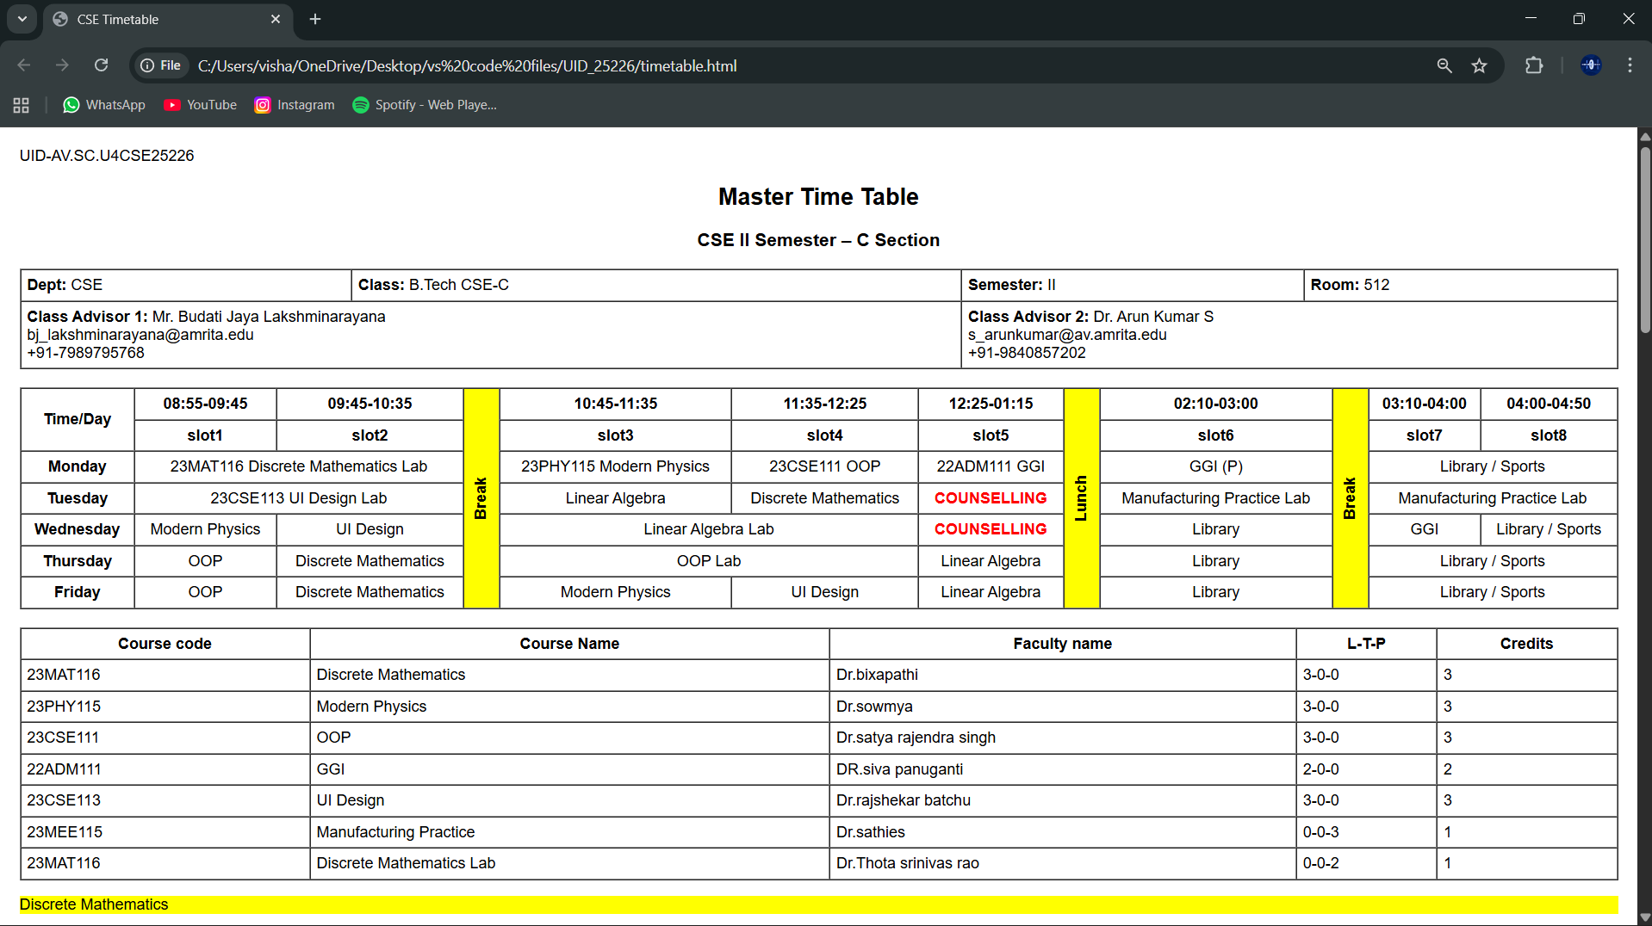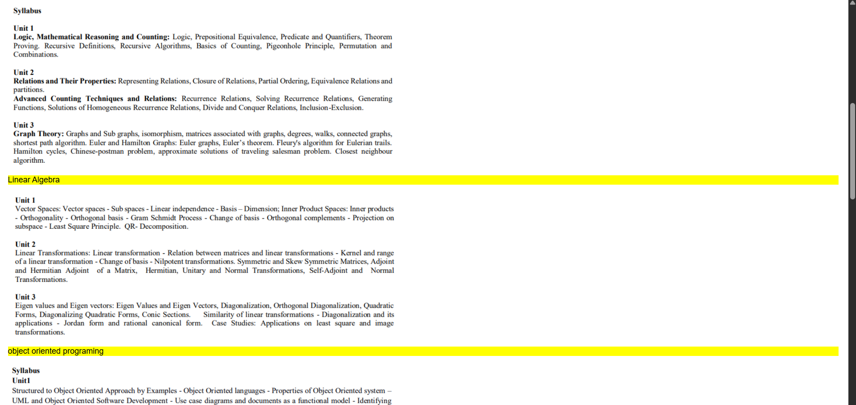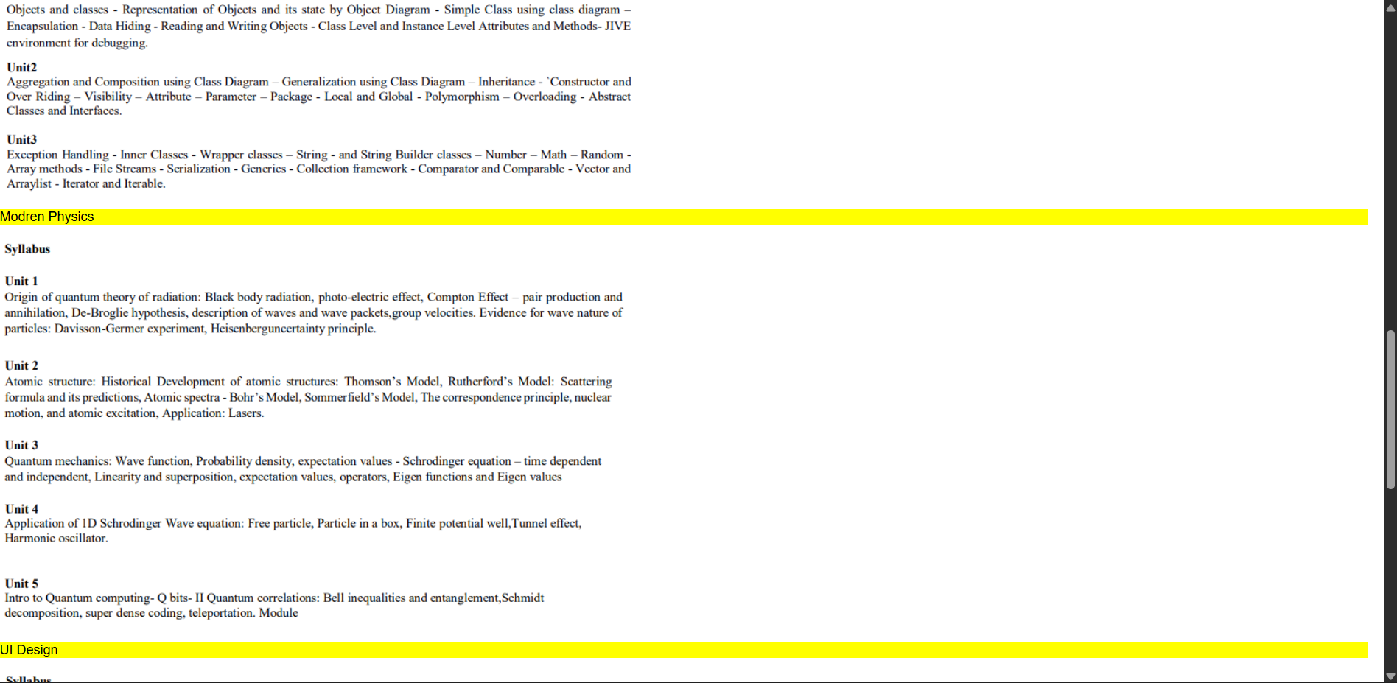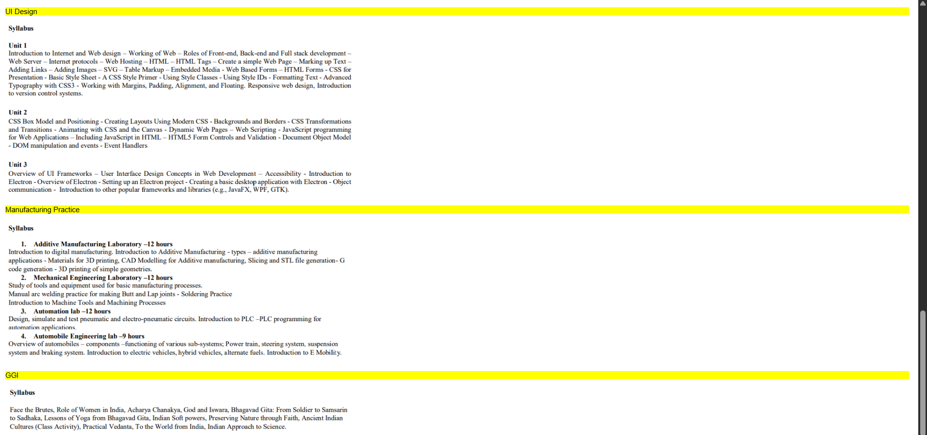-
Explanation:
<DOCTYPE html> : the <!DOCTYPE html> element tells the web browser that this an HTML document
or this is the latest version of HTML
<html> : the <html> element is the root element of an HTML web page
<head> : the <head> element will contain meta data about the HTML web page
<title> : the <title> element specifies a title for the HTML Page
<body> : the <body> element contains all visible content all visible content like text , image , links , tables , etc
In this we use the combined form of the week-1, 3rd one and week-3 1st one . In detail we use the table tags that we used in week-2, 1st program and the image elements from week-1 3rd program by combining both of those tags we get this .
<h> : we used <h> element for heading
<p> : we used <p> element for the paragraph
<table> : we used <table> element for the creation of the table
<tr> : we used <tr> element for creation of row in the table
<td> : we used <td> element for creation of table details
<th> : we used <th> element for creation of table headings
<img> : we used <img> element for adding the images into the web page
And we used colspan and rowspan for combining rows and coloums and scr attribute for adding the image link and we also used style attribute for the colurs and the vertical text and alignment of text.
Week – 4:
4.A)Aim: Design a registration form using only HTML tags (no CSS) with proper labels, table
alignment, background color, and borders.
Program :
UID-AV.SC.U4CSE25226
<!DOCTYPE html>
<html>
<head>
<title>College Admission Registration</title>
</head>
<body bgcolor=”#e6e6fa”>
<center>
<h2>College Admission Registration</h2>
<table border=”2” cellpadding=”8” cellspacing=”0” bgcolor=”#ffffff”>
<tr>
<td><label for=”name”>Full Name:</label></td>
<td><input type=”text” id=”name” name=”name” size=”40”></td>
</tr>
<tr>
<td><label for=”email”>Email:</label></td>
<td><input type=”email” id=”email” name=”email” size=”40”></td>
</tr>
<tr>
<td><label for=”phone”>Phone Number:</label></td>
<td><input type=”tel” id=”phone” name=”phone” size=”40”></td>
</tr>
<tr>
<td>Gender:</td>
<td>
<input type=”radio” name=”gender” value=”male”> Male
<input type=”radio” name=”gender” value=”female”> Female
<input type=”radio” name=”gender” value=”other”> Other
</td>
</tr>
<tr>
<td><label for=”course”>Course Applying For:</label></td>
<td>
<select id=”course” name=”course”>
<option>B.Tech</option>
<option>B.Sc</option>
<option>B.Com</option>
<option>BA</option>
</select>
</td>
</tr>
<tr>
<td>Hobbies:</td>
<td>
<input type=”checkbox” name=”hobby” value=”sports”> Sports
<input type=”checkbox” name=”hobby” value=”music”> Music
<input type=”checkbox” name=”hobby” value=”reading”> Reading
</td>
</tr>
<tr>
<td><label for=”dob”>Date of Birth:</label></td>
<td><input type=”date” id=”dob” name=”dob”></td>
</tr>
<tr>
<td><label for=”file”>Upload Certificates:</label></td>
<td><input type=”file” id=”file” name=”file”></td>
</tr>
<tr>
<td><label for=”address”>Address:</label></td>
<td>
<textarea id=”address” name=”address” rows=”4” cols=”35”></textarea>
</td>
</tr>
<tr align=”center”>
<td colspan=”2”>
<input type=”submit” value=”Submit”>
<input type=”reset” value=”Reset”>
</td>
</tr>
</table>
</center>
</body>
</html>

Output :
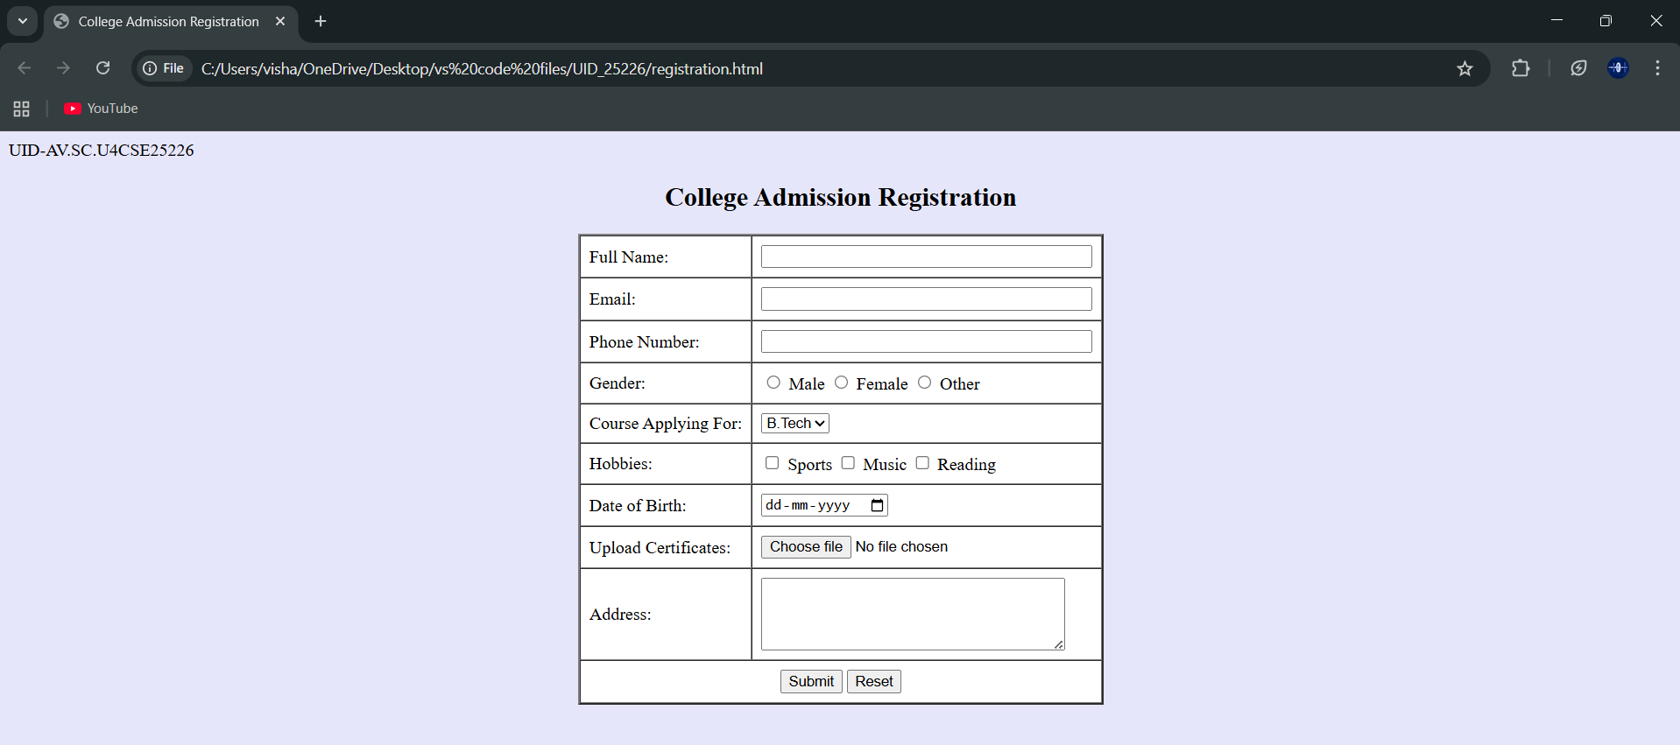
Explanation :
<DOCTYPE html> : the <!DOCTYPE html> element tells the web browser that this an HTML document
or this is the latest version of HTML
<html> : the <html> element is the root element of an HTML web page
<head> : the <head> element will contain meta data about the HTML web page
<title> : the <title> element specifies a title for the HTML Page
<body> : the <body> element contains all visible content all visible content like text , image , links ,
tables , etc
<h> : we used <h> element for heading
<p> : we used <p> element for the paragraph
<table>: the element <table> is used to create a table
<tr>: the element <tr> creates a new row in the table
<th>: the element <th> create a new heading inside the table
<td>: the element <td> fill the columns in the row
<label>:we used <label> element for linking the input to specific id name and we use for attribute for it
<input>:we use <input> element for the input elements in the forms
<select>:we use <select> element for creation of drop box
<option>:we use <option> element for creating the options in the drop box
And we use style attribute for styling and designing the webpage and type for selecting the type of input that is going to In it and for and id tag is used to link the input to label.

4.B)Aim: Two forms displayed side by side using iframes .one is login and another registration
Program :
Main code with Iframes:
UID-AV.SC.U4CSE25226
<!DOCTYPE html>
<html>
<head>
<title>Two Forms Using Iframes</title>
</head>
<body bgcolor=”#e6e6cc”>
<h2 align=”center”>Two Forms Displayed Using Iframes</h2>
<table align=”center” cellpadding=”20”>
<tr>
<td>
<iframe src=”login.html” width=”350” height=”300”></iframe>
</td>
<td>
<iframe src=”register.html” width=”350” height=”300”></iframe>
</td>
</tr>
</table>
</body>
</html>
Login.html:
UID-AV.SC.U4CSE25226
<!DOCTYPE html>
<html>
<head>
<title>Login Form</title>
</head>
<body>
<h3 align=”center”>User Login</h3>
<form>
<table border=”1” align=”center” cellpadding=”8”>
<tr>
<td><label for=”username”>Username:</label></td>
<td><input type=”text” id=”username” name=”username”></td>
</tr>
<tr>
<td><label for=”password”>Password:</label></td>
<td><input type=”password” id=”password” name=”password”></td>
</tr>
<tr align=”center”>
<td colspan=”2”>
<input type=”submit” value=”Login”>
</td>
</tr>
</table>
</form>
</body>
</html>
Register.html:
UID-AV.SC.U4CSE25226
<!DOCTYPE html>
<html>
<head>
<title>Registration Form</title>
</head>
<body>
<h3 align=”center”>User Registration</h3>
<form>
<table border=”1” align=”center” cellpadding=”8”>
<tr>
<td><label for=”name”>Full Name:</label></td>
<td><input type=”text” id=”name” name=”name”></td>
</tr>
<tr>
<td><label for=”email”>Email:</label></td>
<td><input type=”email” id=”email” name=”email”></td>
</tr>
<tr>
<td><label for=”phone”>Phone:</label></td>
<td><input type=”tel” id=”phone” name=”phone”></td>
</tr>
<tr>
<td>Password:</td>
<td><input type=”password” name=”password”></td>
</tr>
<tr align=”center”>
<td colspan=”2”>
<input type=”submit” value=”Register”>
<input type=”reset” value=”Reset”>
</td>
</tr>
</table>
</form>
</body>
</html>
Output :
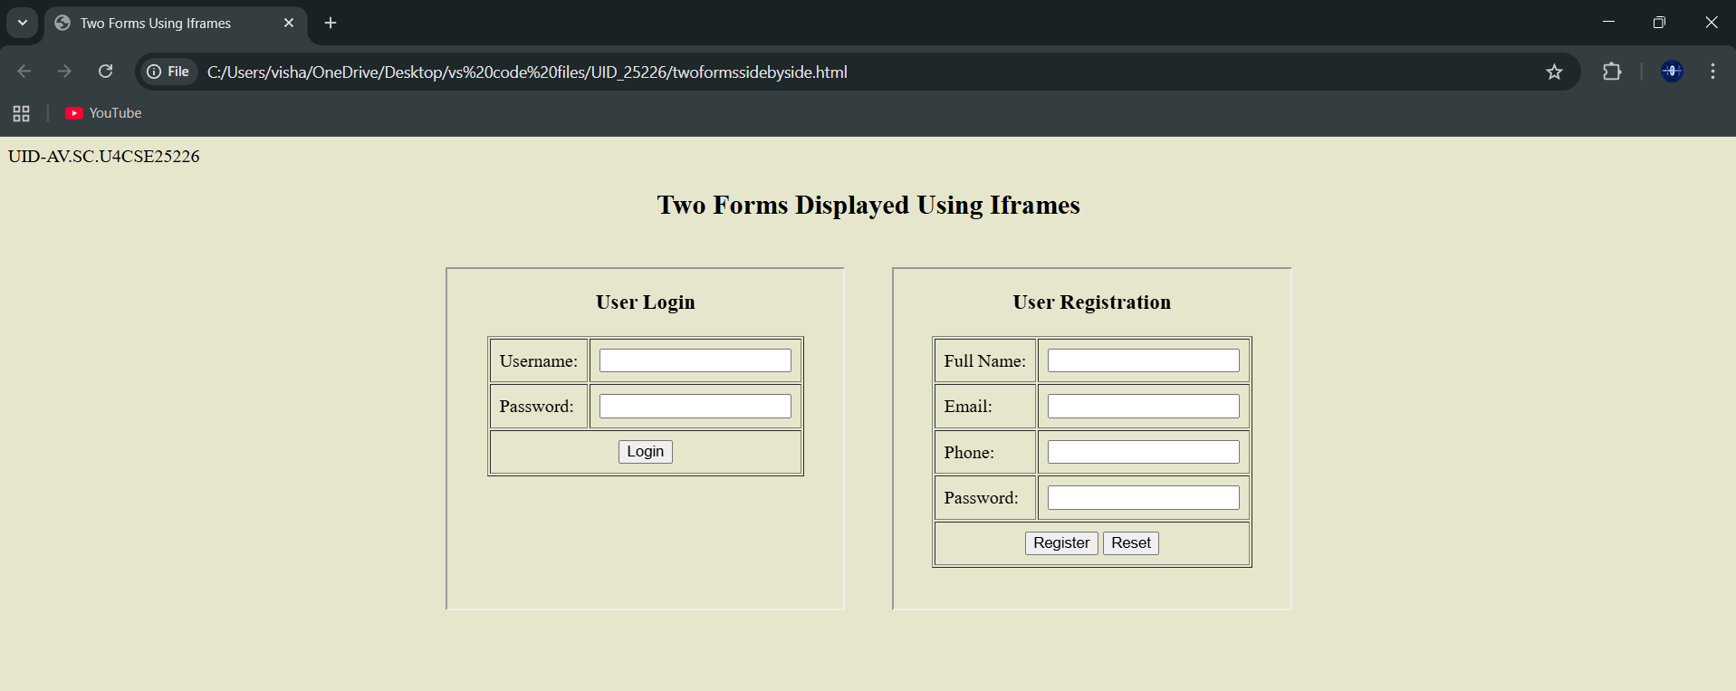
Explanation :
<DOCTYPE html> : the <!DOCTYPE html> element tells the web browser that this an HTML document
or this is the latest version of HTML
<html> : the <html> element is the root element of an HTML web page
<head> : the <head> element will contain meta data about the HTML web page
<title> : the <title> element specifies a title for the HTML Page
<body> : the <body> element contains all visible content all visible content like text , image , links ,
tables , etc
<h> : we used <h> element for heading
<p> : we used <p> element for the paragraph
<table>: the element <table> is used to create a table
<tr>: the element <tr> creates a new row in the table
<th>: the element <th> create a new heading inside the table
<td>: the element <td> fill the columns in the row
<label>:we used <label> element for linking the input to specific id name and we use for attribute for it
<input>:we use <input> element for the input elements in the forms
<select>:we use <select> element for creation of drop box
<option>:we use <option> element for creating the options in the drop box
<iframes>:we use <iframes> element for adding anoter html file to main html file
And we use style attribute for styling and designing the webpage and type for selecting the type of input that is going to In it and for and id tag is used to link the input to label and use the iframe for use the table and add two iframes in two boxes

Week-5:
5.A)Aim: creating a card layout using <div> tag consider three cards and a button using html and css
Program :
UID-AV.SC.U4CSE25226
<!DOCTYPE html>
<html>
<head>
<title>Marvel Super Heroes</title>
<style>
body{
font-family:Arial;
background:#0f172a;
text-align:center;
}
h1{
background:#b91c1c;
padding:20px;
}
.container{
display:flex;
flex-wrap:wrap;
justify-content:center;
gap:20px;
padding:30px;
}
.card{
background:white;
color:black;
width:260px;
padding:20px;
border-radius:12px;
box-shadow:0 5px 15px gray;
}
.hero-img{
width:150px;
height:200px;
object-fit:cover;
border-radius:8px;
}
button{
padding:8px 16px;
border:none;
background:#b91c1c;
color:white;
border-radius:6px;
}
button:hover{
background:black;
}
</style>
</head>
<body>
<h1>Marvel Super Heroes</h1>
<div class=”container”>
<div class=”card”>
<img class=”hero-img”
src=”C:\Users\visha\OneDrive\Pictures\Screenshots\cap.jpg”>
<h3>Captain America</h3>
<p>Winter Soldier</p>
<button>Know More</button>
</div>
<div class=”card”>
<img class=”hero-img”
src=”C:\Users\visha\OneDrive\Pictures\Screenshots\iron.jpg”>
<h3>Iron Man</h3>
<p>Tony Stark</p>
<button>Know More</button>
</div>
<div class=”card”>
<img class=”hero-img”
src=”C:\Users\visha\OneDrive\Pictures\Screenshots\thor.jpg”>
<h3>Thor</h3>
<p>Odinson</p>
<button>Know More</button>
</div>
</div>
</body>
</html>
Output :
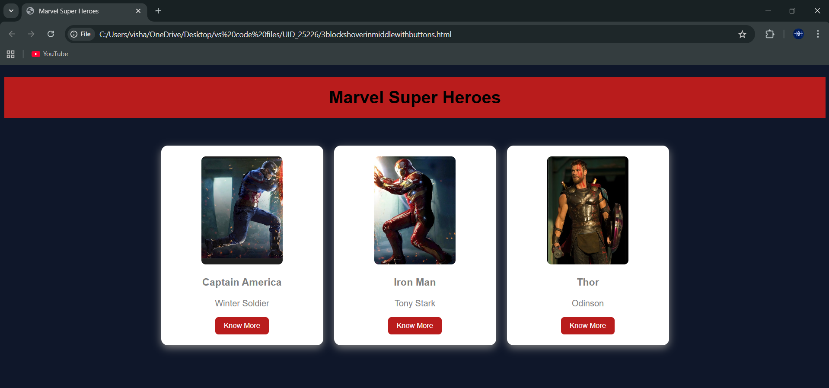
Explanation :
<DOCTYPE html> : the <!DOCTYPE html> element tells the web browser that this an HTML document
or this is the latest version of HTML
<html> : the <html> element is the root element of an HTML web page
<head> : the <head> element will contain meta data about the HTML web page
<title> : the <title> element specifies a title for the HTML Page
<body> : the <body> element contains all visible content all visible content like text , image , links ,
tables , etc
<h> : we used <h> element for heading
<p> : we used <p> element for the paragraph
<div>:we use <div> element for encapsulating the the divisions and easy to modify and
<button>: we use <button> element for button
<img>: we use <img> tag for displaying the image
And we internal css for the html page and use element and class selector to apply the css to the div elements and src attribute for image path ,by using the class and internal css we created this webpage

5.B)Aim: Navigation using iframe (mini website) upon clicking each buttons the details about that
button should be display on the same page
program:
ironmain.htmlmain)
UID-AV.SC.U4CSE25226
<!DOCTYPE html>
<html>
<head>
<title>Iron Man</title>
<style>
body{margin:0;font-family:Arial;background-color: gray;}
.menu{
background:#b91c1c;
padding:15px;
text-align:center;
}
.menu a{
color:white;
margin:0 15px;
text-decoration:none;
background:black;
padding:8px 12px;
}
iframe{
width:100%;
height:400px;
border:none;
}
</style>
</head>
<body>
<h1 style=”text-align:center;background:#b91c1c;color:white;padding:20px;”>Iron Man</h1>
<div class=”menu”>
<a href=”strengths.html” target=”frame”>Strengths & Weaknesses</a>
<a href=”personal.html” target=”frame”>Personal Info</a>
<a href=”contribution.html” target=”frame”>Contributions</a>
</div>
<iframe name=”frame”></iframe>
</body>
</html>
Strengths.html(sub)
UID-AV.SC.U4CSE25226
<!DOCTYPE html>
<html>
<head>
<style>
body{font-family:Arial;text-align:center;}
.box{
border:2px solid black;
padding:20px;
display:inline-block;}
h2{color:#b91c1c;}
</style>
</head>
<body>
<div class=”box”>
<h2>Strengths and Weaknesses</h2>
<p>Strengths: Genius mind, powerful armor.</p>
<p>Weaknesses: Ego, suit dependency.</p>
<img src=”C:\Users\visha\OneDrive\Pictures\Screenshots\iron31.png” alt=”Iron Man” style=”width:200px;height:200px;”>
</div>
</body>
</html>
Personal.htmlsub)
UID-AV.SC.U4CSE25226
<!DOCTYPE html>
<html>
<head>
<style>
body{font-family:Arial;text-align:center}
.box{
border:2px solid black;
padding:20px;
display:inline-block;}
h2{color:#b91c1c;}
</style>
</head>
<body>
<div class=”box”>
<h2>Personal Information</h2>
<p>Name: Tony Stark</p>
<p>Company: Stark Industries</p>
<p>Team: Avengers</p>
<img src=”C:\Users\visha\OneDrive\Pictures\Screenshots\iron32.png” alt=”Tony Stark” style=”width:200px;margin-top:20px;”>
</div>
</html>
Contribution.html:(sub)
UID-AV.SC.U4CSE25226
<!DOCTYPE html>
<html>
<head>
<style>
body{font-family:Arial;text-align:center}
.box{
border:2px solid black;
padding:20px;
display:inline-block;}
h2{color:#b91c1c;}
</style>
</head>
<body>
<div class=”box”>
<h2>Contributions</h2>
<p>Built Iron Man suits.</p>
<p>Helped defeat Thanos.</p>
<p>Saved Earth many times.</p>
<img src=”C:\Users\visha\OneDrive\Pictures\Screenshots\iron33.png” alt=”Iron Man” style=”width:200px;margin-top:20px;”>
</div>
</body>
</html>
Output :
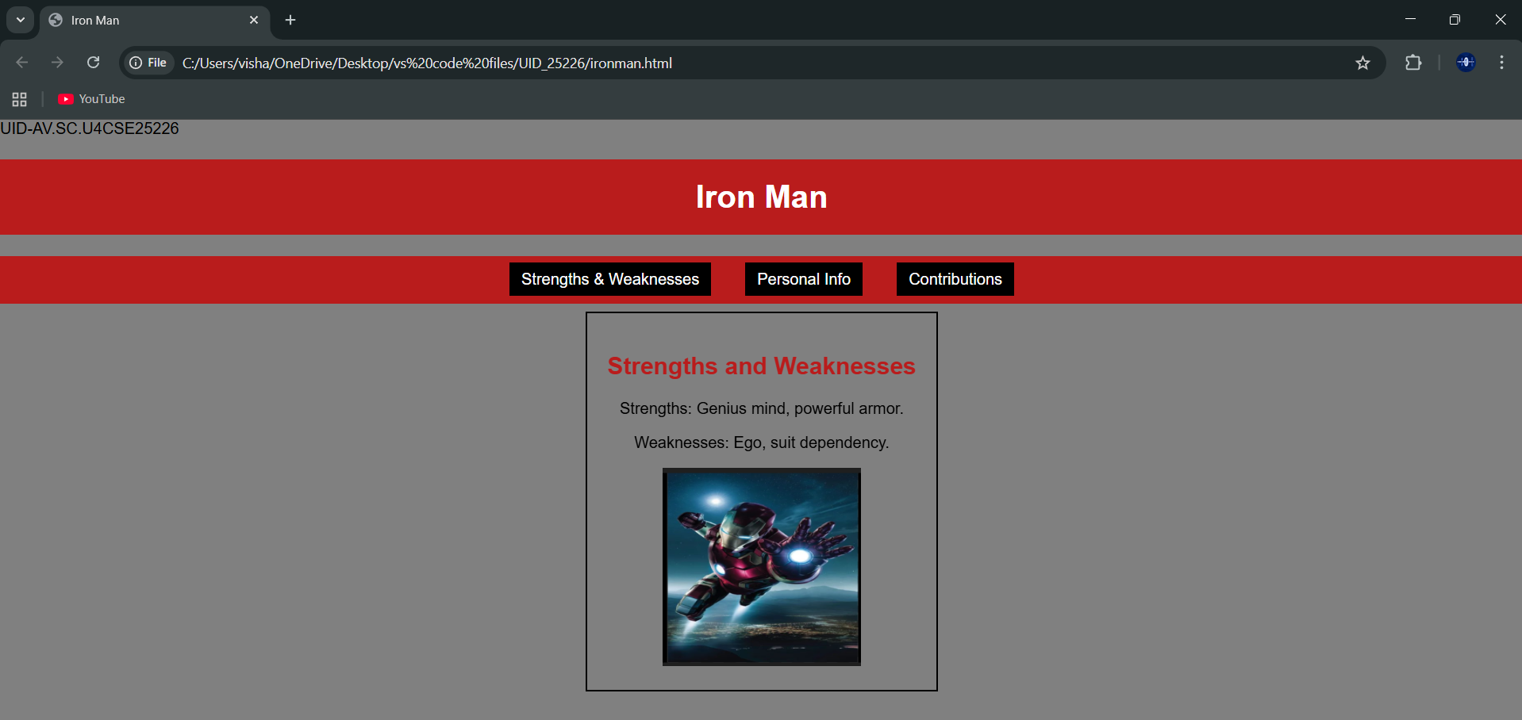
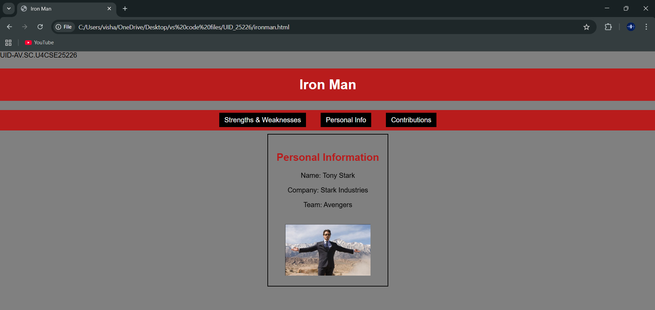
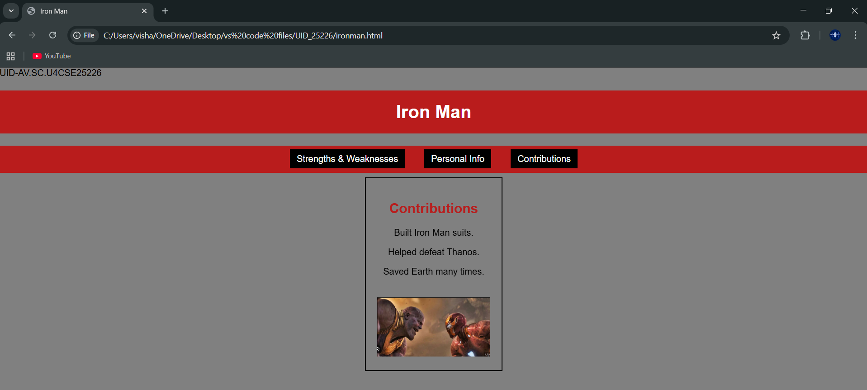
Explanation :
<DOCTYPE html> : the <!DOCTYPE html> element tells the web browser that this an HTML document
or this is the latest version of HTML
<html> : the <html> element is the root element of an HTML web page
<head> : the <head> element will contain meta data about the HTML web page
<title> : the <title> element specifies a title for the HTML Page
<body> : the <body> element contains all visible content all visible content like text , image , links ,
tables , etc
<h> : we used <h> element for heading
<p> : we used <p> element for the paragraph
<div>:we use <div> element for encapsulating the the divisions and easy to modify and
<button>: we use <button> element for button
<img>: we use <img> tag for displaying the image
And we internal css for the html page and use element and class selector to apply the css to the div elements and src attribute for image path ,by using the class and internal css we created this webpage and href attribute is used to link the html pages to the main webpage and use target attribute to link the anchor element to href attribute . and the three webpages are linked to main webpage .and inline attribute for the boder to wrap around it .

5.c)Aim: Design amrita login page by showcampus on home page.upon clicking on each campus
the details about each campus should be display on the same page use html and css to
design a stylish webpage
program:
Main file:
AV.SC.U4CSE25226-UID
<!DOCTYPE html>
<html>
<head>
<title>Amrita Vishwa Vidhyapeetam</title>
<style>
body{margin:0;font-family:Arial;background:rgb(101, 101, 139);}
header{background:#a00000;color:#fff;text-align:center;
padding:20px;font-size:36px;}
nav{background:#0b5ea6;text-align:center;padding:10px;}
nav a{color:yellow;margin:12px;text-decoration:none;
font-weight:bold;padding:5px;}
nav a:hover{background:#fff;color:#0b5ea6;
border-radius:5px;}
main{display:flex;padding:20px;}
.login{
width:350px;
background:#2ecc71;
padding:15px;
border-radius:10px;
color:white;
}
.login input[type=”email”],
.login input[type=”password”]{
width:90%;
padding:6px;
margin:6px 0;
}
.remember{display:flex;align-items:center;gap:6px;margin:8px 0;}
iframe{
flex:1;
margin-left:20px;
height:520px;
border:none;
background:lightskyblue;
border-radius:10px;
}
</style>
</head>
<body>
<header>AMRITA VISHWA VIDHYAPEETAM</header>
<nav>
<a href=”ranslate.html” target=”campus”>AMARAVATI</a>
<a href=”amritapuri.html” target=”campus”>AMRITAPURI</a>
<a href=”ranslate.html” target=”campus”>BENGALURU</a>
<a href=”ransla.html” target=”campus”>CHENNAI</a>
<a href=”ranslate.html” target=”campus”>COIMBATORE</a>
<a href=”ranslate.html” target=”campus”>FARIDABAD</a>
<a href=”kochi.html” target=”campus”>KOCHI</a>
<a href=”ransl.html” target=”campus”>MYSURU</a>
</nav>
<main>
<div class=”login”>
<h2>Login</h2>
Email
<input type=”email”>
Password
<input type=”password”>
<div class=”remember”>
<input type=”checkbox”><label>Save me</label>
</div>
<input type=”button” value=”Login” style=”width:100%;padding:6px;”>
<br><br>
<a href=”#”>Forgot Password?</a><br>
No account? <a href=”#”>Register</a>
</div>
<iframe name=”campus” src=”ranslate.html”></iframe>
</main>
</body>
</html>
Amaravathi:
<!DOCTYPE html>
<html>
<body style=”font-family:Arial; text-align:center; padding:30px;”>
<h1 style=”color:#a00000;”>Amaravati Campus</h1>
<p>
Amrita Amaravati campus is located near the Krishna River in Andhra Pradesh.
It provides modern classrooms, research labs, and excellent hostel facilities.
</p>
<p>
Popular Courses: CSE, AI, Data Science<br>
Facilities: Library, Smart Classrooms, Hostel<br>
Focus: Innovation and Research
</p>
<img src=”C:\Users\visha\OneDrive\Pictures\Screenshots\amaravathi.png” width=”450”>
</body>
</html>
Bengluru:
<!DOCTYPE html>
<html>
<body style=”font-family:Arial;text-align:center;padding:30px;”>
<h1 style=”color:#a00000;”>Bengaluru Campus</h1>
<p>
Located in India’s tech hub, Bengaluru campus offers advanced
engineering programs with strong industry connections.
</p>
<p>
Popular Courses: Robotics, CSE, ECE<br>
Facilities: Coding Labs, Innovation Centres<br>
Focus: Industry Collaboration
</p>
<img src=”C:\Users\visha\OneDrive\Pictures\Screenshots\benguluru.png” width=”450”>
</body>
</html>
Amritapuri:
<!DOCTYPE html>
<html>
<body style=”font-family:Arial;text-align:center;padding:30px;”>
<h1 style=”color:#a00000;”>Amritapuri Campus</h1>
<p>
Amritapuri campus in Kerala is the main campus of Amrita University,
located near the Arabian Sea with a peaceful academic atmosphere.
</p>
<p>
Popular Courses: Engineering, Arts, Sciences<br>
Facilities: Research Labs, Beach Campus, Hostel<br>
Focus: Academic Excellence with Values
</p>
<img src=”C:\Users\visha\OneDrive\Pictures\Screenshots\amritapuri.png” width=”450”>
</body>
</html>
Chennai:
<!DOCTYPE html>
<html>
<body style=”font-family:Arial;text-align:center;padding:30px;”>
<h1 style=”color:#a00000;”>Chennai Campus</h1>
<p>
Chennai campus provides top-quality computing and management education
with modern infrastructure and placement support.
</p>
<p>
Popular Courses: IT, MBA, Electronics<br>
Facilities: Digital Library, Placement Cell<br>
Focus: Career Development
</p>
<img src=”C:\Users\visha\OneDrive\Pictures\Screenshots\chennai.png” width=”450”>
</body>
</html>
Coiambatore:
<!DOCTYPE html>
<html>
<body style=”font-family:Arial;text-align:center;padding:30px;”>
<h1 style=”color:#a00000;”>Coimbatore Campus</h1>
<p>
Coimbatore campus is well known for its engineering excellence
and research-oriented education.
</p>
<p>
Popular Courses: Mechanical, Civil, CSE<br>
Facilities: Workshops, Labs, Hostel<br>
Focus: Core Engineering Skills
</p>
<img src=”C:\Users\visha\OneDrive\Pictures\Screenshots\coimbatore.png” width=”450”>
</body>
</html>
Faridabadh:
<!DOCTYPE html>
<html>
<body style=”font-family:Arial;text-align:center;padding:30px;”>
<h1 style=”color:#a00000;”>Faridabad Campus</h1>
<p>
Faridabad campus focuses on medical and healthcare education
with advanced hospital training facilities.
</p>
<p>
Popular Courses: Medical, Nursing, Allied Health<br>
Facilities: Teaching Hospital, Labs<br>
Focus: Healthcare Research
</p>
<img src=”C:\Users\visha\OneDrive\Pictures\Screenshots\faridabadh.png” width=”450”>
</body>
</html>
Kochi:
<!DOCTYPE html>
<html>
<body style=”font-family:Arial;text-align:center;padding:30px;”>
<h1 style=”color:#a00000;”>Kochi Campus</h1>
<p>
Kochi campus offers programs in business, commerce,
and applied sciences with modern facilities.
</p>
<p>
Popular Courses: MBA, Commerce, Finance<br>
Facilities: Seminar Halls, Library<br>
Focus: Industry Training
</p>
<img src=”C:\Users\visha\OneDrive\Pictures\Screenshots\kochi.png” width=”450”>
</body>
</html>
Mysore:
<!DOCTYPE html>
<html>
<body style=”font-family:Arial;text-align:center;padding:30px;”>
<h1 style=”color:#a00000;”>Mysuru Campus</h1>
<p>
Mysuru campus is known for its peaceful environment,
green campus, and quality education.
</p>
<p>
Popular Courses: Arts, Sciences, Engineering<br>
Facilities: Hostel, Library, Sports Complex<br>
Focus: Calm Learning Atmosphere
</p>
<img src=”C:\Users\visha\OneDrive\Pictures\Screenshots\mysur.png” width=”450”>
</body>
</html>
Outout:
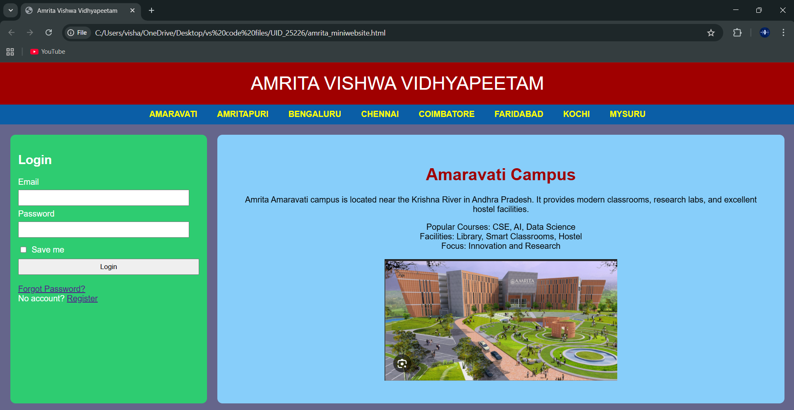
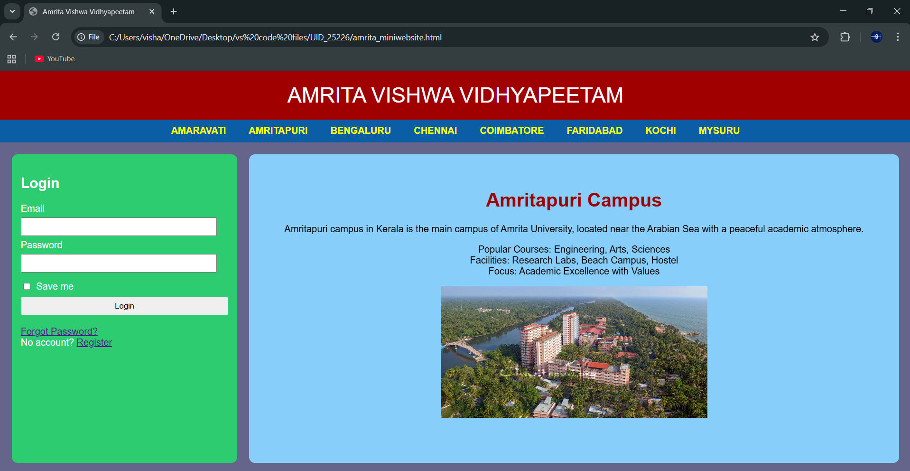
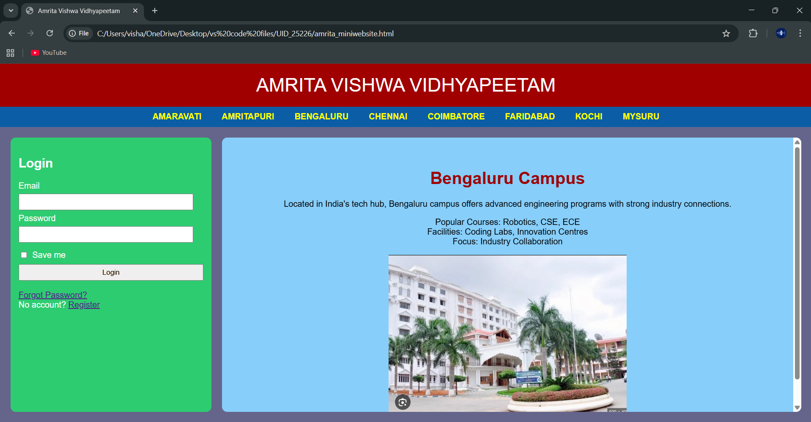
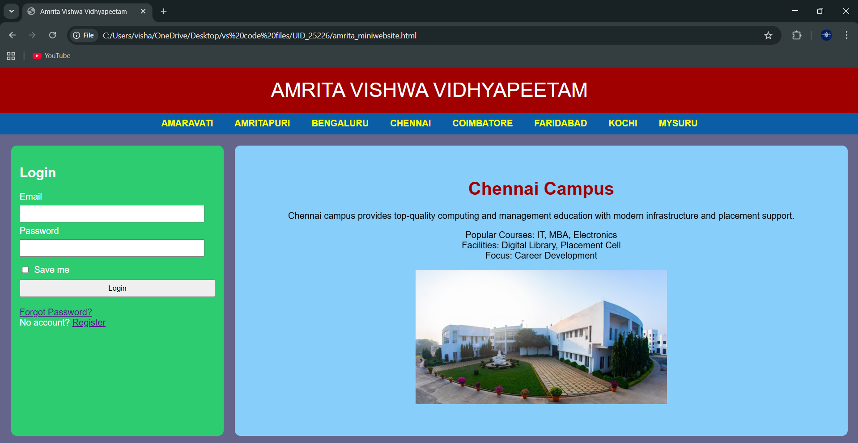
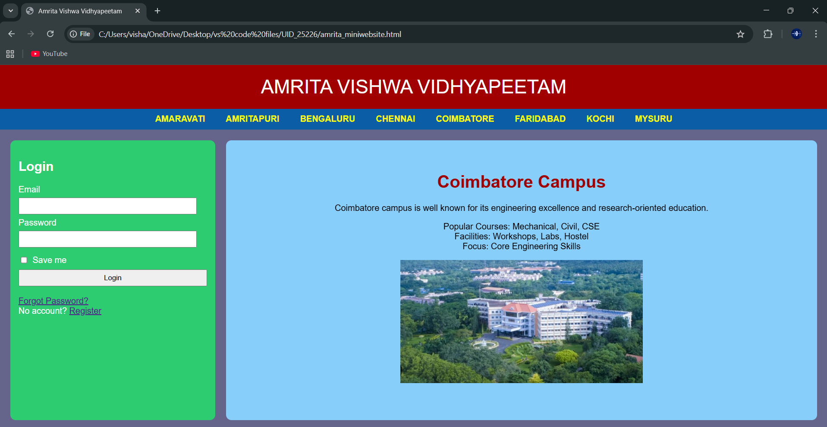
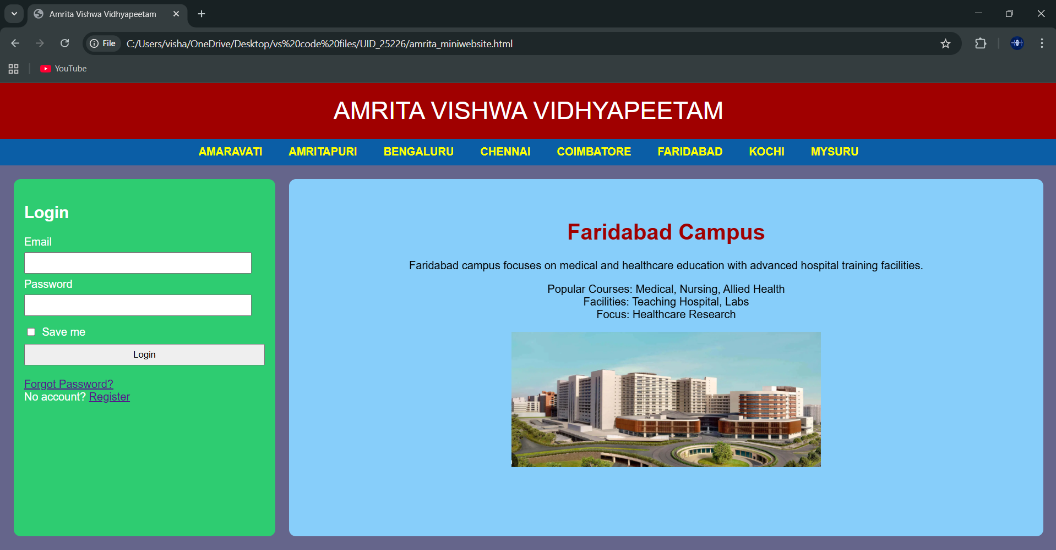
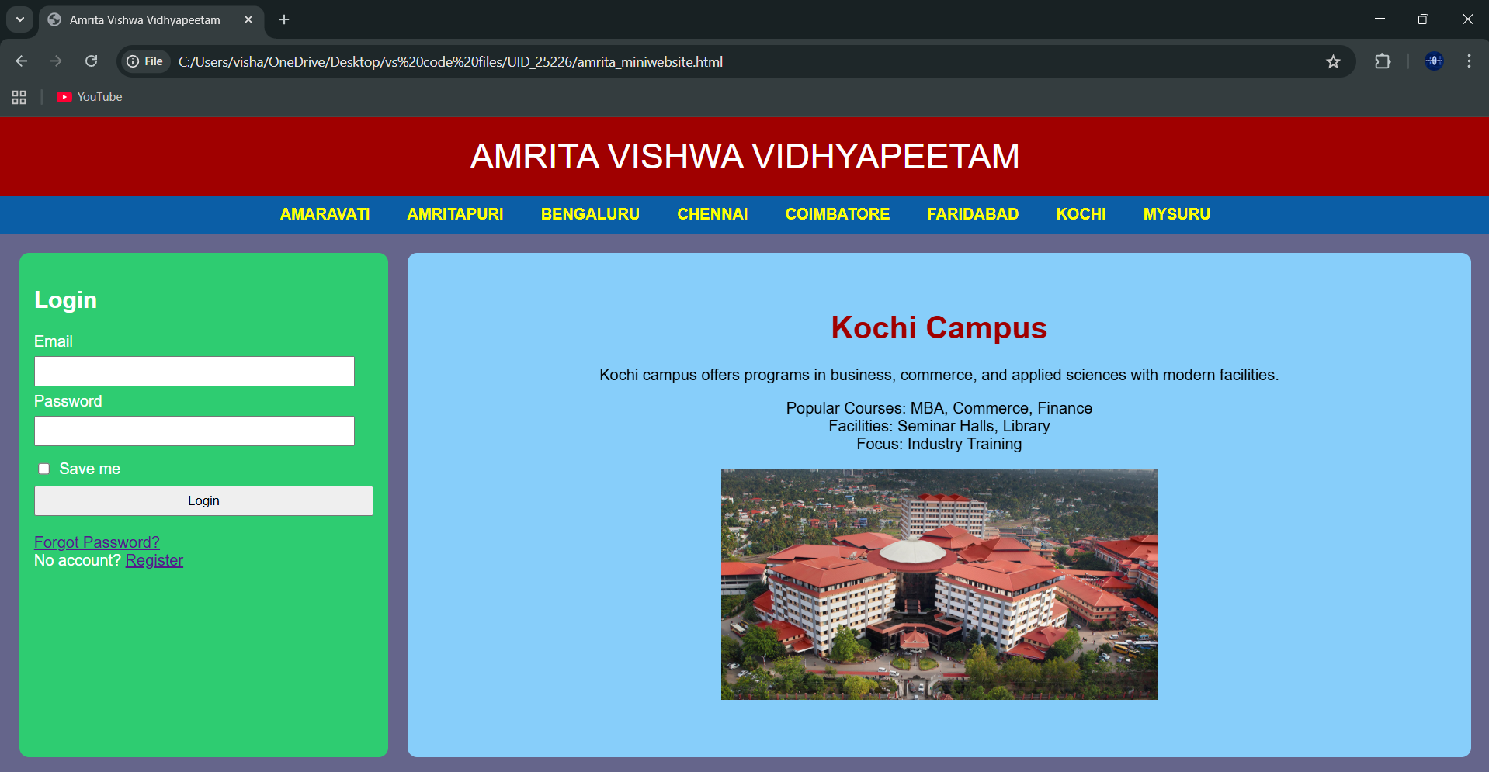
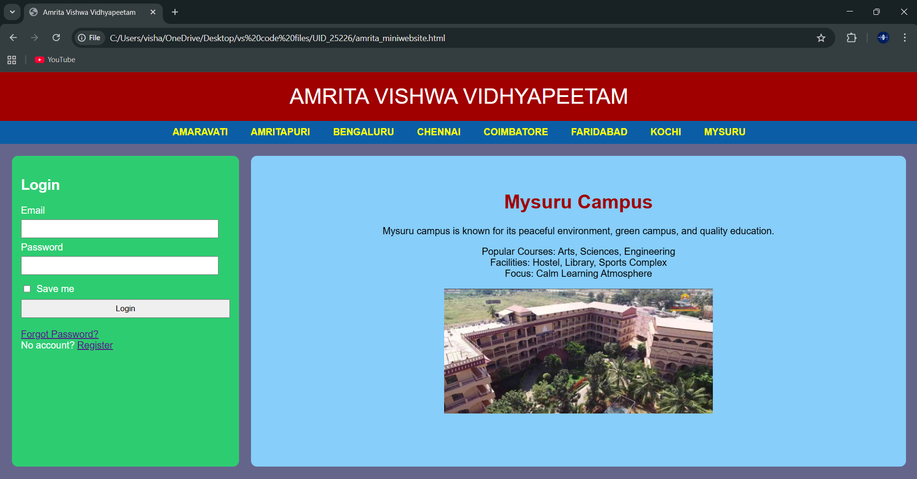
Explanation :
<DOCTYPE html> : the <!DOCTYPE html> element tells the web browser that this an HTML document
or this is the latest version of HTML
<html> : the <html> element is the root element of an HTML web page
<head> : the <head> element will contain meta data about the HTML web page
<title> : the <title> element specifies a title for the HTML Page
<body> : the <body> element contains all visible content all visible content like text , image , links ,
tables , etc
<h> : we used <h> element for heading
<p> : we used <p> element for the paragraph
<div>:we use <div> element for encapsulating the the divisions and easy to modify and
<button>: we use <button> element for button
<img>: we use <img> tag for displaying the image
<Iframes>:we use <iframe> element for creating the login block that stays left to it
We used different types of input attributes for different inputs
And we internal css for the html page and use element and class selector to apply the css to the div elements and src attribute for image path ,by using the class and internal css we created this webpage and href attribute is used to link the html pages to the main webpage and use target attribute to link the anchor element to href attribute . and the three webpages are linked to main webpage .and inline attribute for the boder to wrap around it .
We used iframes and target attributes to link the iframes to the webpage and the all the required I frame attributes are used in it and

Week-6:
6.A) Aim: Design a responsive e-commerce application using the grid layout. This application should contain different categories of products such as electronics, clothing, home-appliances, books.
Program :
AV.SC.U4CSE25226-UID
<!DOCTYPE html>
<html>
<head>
<title>My E-commerce Website</title>
<style>
body{
font-family: Arial, sans-serif;
margin: 0;
padding: 0;
background-color: black;
}
.container{
display: grid;
grid-template-rows: auto auto 1fr auto;
grid-template-columns: 200px 1fr;
grid-template-areas:
“header header”
“sale sale”
“sidebar main”
“footer footer”;
gap: 10px;
padding: 10px;
}
.header{
grid-area: header;
background-color:gray ;
padding: 10px;
text-align: center;
}
.sale{
grid-area: sale;
background-color: gray;
padding: 10px;
text-align: center;
}
.sidebar{
grid-area: sidebar;
background-color: gray;
padding: 10px;
}
.main{
grid-area: main;
background-color: gray;
padding: 10px;
display: grid;
grid-template-columns: repeat(2, 1fr);
gap: 10px;
}
.footer{
grid-area: footer;
background-color: gray;
padding: 10px;
text-align: center;
}
.product{
background-color:lightgray;
padding: 10px;
border-radius: 5px;
text-align: center;
}
.product-image{
width: 200px;
height: 200px;
}
.button{
background-color: grey;
color: black;
border: 2px solid white;
padding: 10px 20px;
border-radius: 5px;
}
.button:hover{
background-color: lightslategray;
color: black;
border: 2px solid black;
}
</style>
</head>
<body>
<div class=”container”>
<div class=”header”>
<h1>TOYS 4 TOYS</h1>
</div>
<div class=”sale”>
<p>Special Sale!</p>
</div>
<div class=”sidebar”>
<h2>Categories</h2>
<ul>
<li>RC CARS</li>
<li>LEGOS</li>
<li>HAPTIC TOYS</li>
<li>BOARD GAMES</li>
</ul>
</div>
<div class=”main”>
<div class=”product”>
<img class=”product-image” src=”C:\Users\visha\OneDrive\Pictures\Screenshots\rc car.webp” alt=”RC Car”>
<h3>RC Car</h3>
<p>Price: $29.99</p>
<button class=”button”>Add to Cart</button>
</div>
<div class=”product”>
<img class=”product-image” src=”C:\Users\visha\OneDrive\Pictures\Screenshots\lego.jpg” alt=”LEGO Set”>
<h3>LEGO Set</h3>
<p>Price: $49.99</p>
<button class=”button”>Add to Cart</button>
</div>
<div class=”product”>
<img class=”product-image” src=”C:\Users\visha\OneDrive\Pictures\Screenshots\haptic.jpg” alt=”Haptic Toy”>
<h3>Haptic Toy</h3>
<p>Price: $19.99</p>
<button class=”button”>Add to Cart</button>
</div>
<div class=”product”>
<img class=”product-image” src=”C:\Users\visha\OneDrive\Pictures\Screenshots\monopoly.jpg” alt=”Board Game”>
<h3>Board Game</h3>
<p>Price: $39.99</p>
<button class=”button”>Add to Cart</button>
</div>
</div>
<div class=”footer”>
<p>&copy; copyright TOYS 4 TOYS Website. All rights reserved.</p>
</div>
</div>
</body>
</html>
Output:
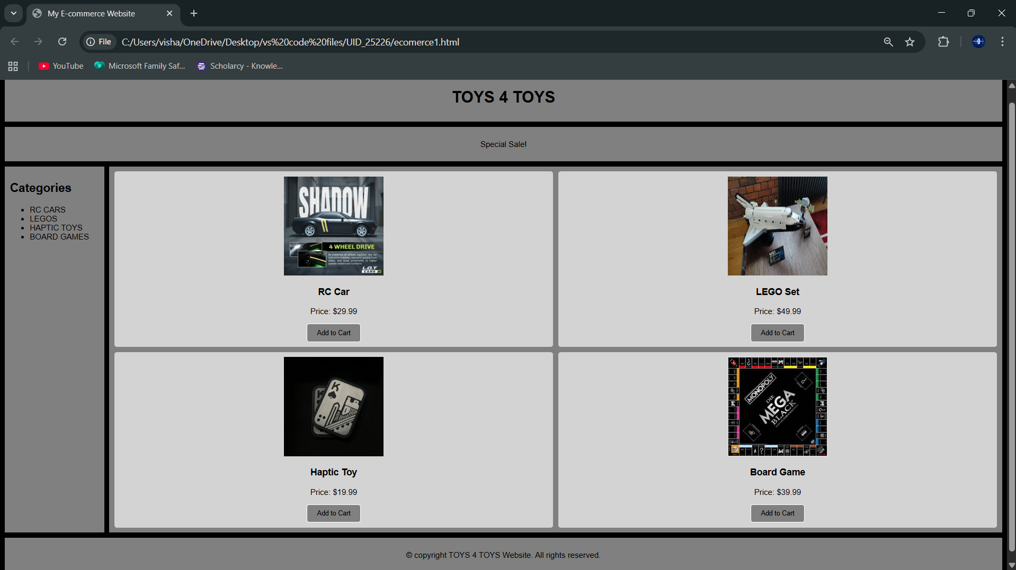
Explanation:
<DOCTYPE html> : the <!DOCTYPE html> element tells the web browser that this an HTML document
or this is the latest version of HTML
<html> : the <html> element is the root element of an HTML web page
<head> : the <head> element will contain meta data about the HTML web page
<title> : the <title> element specifies a title for the HTML Page
<body> : the <body> element contains all visible content all visible content like text , image , links ,
tables , etc
<h> : we used <h> element for heading
<p> : we used <p> element for the paragraph
<div>:we use <div> element for encapsulating the the divisions and easy to modify and
<button>: we use <button> element for button
<img>: we use <img> tag for displaying the image
We used layout in this program and its attributes like grid-template-rows, grid-template-coloums, grid-template-area to define the items space for the grid layout by dividing page into separate sections and use div tag make into small separate blocks
6.B) Aim: Design a responsive e-commerce application using the grid layout. This application should contain different categories of products such as electronics, clothing, home-appliances, books. Based on the category we select corresponding products should be displayed on the sidebar.
Program:
Main:
AV.SC.U4CSE25226-UID
<!DOCTYPE html>
<html>
<head>
<title>TOYS 4 TOYS</title>
<style>
body{
margin:0;
font-family:Arial;
color:#fff;
background:url(“backgroundimages.jpg”) center/cover fixed no-repeat;
}
body::before{
content:””;
position:fixed;
inset:0;
background:rgba(0,0,0,.75);
z-index:-1;
}
.container{
display:grid;
grid-template:
“header header” auto
“sale sale” auto
“sidebar main” 1fr
“footer footer” auto /220px 1fr;
gap:15px;
padding:15px;
}
.header,.sale,.sidebar,.main,.footer{
background:rgba(40,40,40,.65);
border-radius:12px;
padding:15px;
box-shadow:0 0 15px #000;
}
.header{grid-area:header;text-align:center;font-size:28px;letter-spacing:3px;}
.sale{grid-area:sale;overflow:hidden;white-space:nowrap;height:40px;position:relative;}
.sale p{
position:absolute;
color:#00ffd5;
font-size:20px;
animation:move 10s linear infinite;
}
@keyframes move{
from{left:-100%;}
to{left:100%;}
}
.sidebar{grid-area:sidebar}
.sidebar ul{list-style:none;padding:0}
.sidebar li{margin:15px 0}
.sidebar a{
color:#fff;
text-decoration:none;
font-size:18px;
transition:.3s;
}
.sidebar a:hover{color:#00ffd5;padding-left:8px}
.main{grid-area:main}
iframe{width:100%;height:520px;border:0;background:rgba(0,0,0,.5);border-radius:10px}
.footer{grid-area:footer;text-align:center;font-size:14px;opacity:.85}
</style>
</head>
<body>
<div class=”container”>
<div class=”header”>TOYS 4 TOYS</div>
<div class=”sale”>
<p>🔥 SPECIAL SALE – UP TO 50% OFF ON ALL TOYS 🔥</p>
</div>
<div class=”sidebar”>
<h2>Categories</h2>
<ul>
<li><a href=”rc-cars.html” target=”contentFrame”>RC CARS</a></li>
<li><a href=”legos.html” target=”contentFrame”>LEGOS</a></li>
<li><a href=”haptic-toys.html” target=”contentFrame”>HAPTIC TOYS</a></li>
<li><a href=”board-games.html” target=”contentFrame”>BOARD GAMES</a></li>
</ul>
</div>
<div class=”main”>
<iframe name=”contentFrame”></iframe>
</div>
<div class=”footer”>
© TOYS 4 TOYS Website
</div>
</div>
</body>
</html>
Sub1:
<!DOCTYPE html>
<html>
<head>
<title>RC Cars</title>
<style>
body{
font-family: Arial, sans-serif;
margin:0;
padding:20px;
background-color: gray;
}
.container{
display:grid;
grid-template-columns: 1fr 1fr; /* 2 columns */
grid-template-rows: auto auto; /* 2 rows */
gap:20px;
}
.card{
background:white;
padding:20px;
border-radius:10px;
box-shadow:0 4px 10px rgba(0,0,0,0.2);
text-align:center;
}
.card-img{
width:200px;
height:200px;
border-radius:10px;
margin-bottom:10px;
}
.price{
font-size:18px;
color:green;
margin-top:10px;
}
</style>
</head>
<body>
<div class=”container”>
<div class=”card”>
<img class=”card-img” src=”C:\Users\visha\OneDrive\Pictures\Screenshots\flare.jpg” alt=”RC Car 1”>
<h2>FLARE</h2>
<p>High speed remote control car.</p>
<p class=”price”>$29.99</p>
</div>
<div class=”card”>
<img class=”card-img” src=”C:\Users\visha\OneDrive\Pictures\Screenshots\dash.jpg” alt=”RC Car 2”>
<h2>DASH</h2>
<p>Mini remote control car.</p>
<p class=”price”>$34.99</p>
</div>
<div class=”card”>
<img class=”card-img” src=”C:\Users\visha\OneDrive\Pictures\Screenshots\ghost.jpg” alt=”RC Car 3”>
<h2>GHOST</h2>
<p>Drift racing car model.</p>
<p class=”price”>$39.99</p>
</div>
<div class=”card”>
<img class=”card-img” src=”C:\Users\visha\OneDrive\Pictures\Screenshots\rc car.webp” alt=”RC Car 4”>
<h2>SHADOW</h2>
<p>RC drift car</p>
<p class=”price”>$44.99</p>
</div>
</div>
</body>
</html>
Sub2:
<!DOCTYPE html>
<html>
<head>
<title>LEGO Toys</title>
<style>
body{
font-family: Arial, sans-serif;
margin:0;
padding:20px;
background-color: gray;
}
.container{
display:grid;
grid-template-columns: 1fr 1fr; /* 2 columns */
grid-template-rows: auto auto; /* 2 rows */
gap:20px;
}
.card{
background:white;
padding:20px;
border-radius:10px;
box-shadow:0 4px 10px rgba(0,0,0,0.2);
text-align:center;
}
.card-img{
width:200px;
height:200px;
border-radius:10px;
margin-bottom:10px;
}
.price{
font-size:18px;
color:green;
margin-top:10px;
}
</style>
</head>
<body>
<div class=”container”>
<div class=”card”>
<img src=”C:\Users\visha\OneDrive\Pictures\Screenshots\lego.jpg” alt=”lego” class=”card-img”>
<h2>LEGO SHUTTEL</h2>
<p>space ransla</p>
<p class=”price”>$19.99</p>
</div>
<div class=”card”>
<img src=”C:\Users\visha\OneDrive\Pictures\Screenshots\lego3.jpg” alt=”lego space” class=”card-img”>
<h2>TAJ MAHAL</h2>
<p>beautiful ransl architecture</p>
<p class=”price”>$24.99</p>
</div>
<div class=”card”>
<img src=”C:\Users\visha\OneDrive\Pictures\Screenshots\lego4.jpg” alt=”lego police” class=”card-img”>
<h2>colloseum</h2>
<p>ancient roman amphitheater</p>
<p class=”price”>$29.99</p>
</div>
<div class=”card”>
<img src=”C:\Users\visha\OneDrive\Pictures\Screenshots\lego marvel.avif” alt=”lego racing” class=”card-img”>
<h2>LEGO STARK TOWER</h2>
<p>Build a towering LEGO structure.</p>
<p class=”price”>$34.99</p>
</div>
</div>
</body>
</html>
Sub3:
<!DOCTYPE html>
<html>
<head>
<title>Haptic Toys</title>
<style>
body{
font-family: Arial, sans-serif;
margin:0;
padding:20px;
background-color: gray;
}
.container{
display:grid;
grid-template-columns: 1fr 1fr;
gap:20px;
}
.card{
background:white;
padding:20px;
border-radius:10px;
box-shadow:0 4px 10px rgba(0,0,0,0.2);
text-align:center;
}
.card-image{
width:200px;
height:200px;
border-radius:10px;
margin-bottom:10px;
}
.price{
font-size:18px;
color:green;
margin-top:10px;
}
</style>
</head>
<body>
<div class=”container”>
<div class=”card”>
<img src=”C:\Users\visha\OneDrive\Pictures\Screenshots\haptic.jpg” alt=”haptic” class=”card-image”>
<h2>LAUTTIE SHUFFEL</h2>
<p>Fun magnetic slider toy for stress relief.</p>
<p class=”price”>$9.99</p>
</div>
<div class=”card”>
<img src=”C:\Users\visha\OneDrive\Pictures\Screenshots\shuffel2.jpg” alt=”haptic fidget” class=”card-image”>
<h2>LAUTTIE SHUFFEL 2</h2>
<p>Fun magnetic slider toy for stress relief.</p>
<p class=”price”>$14.99</p>
</div>
<div class=”card”>
<img src=”C:\Users\visha\OneDrive\Pictures\Screenshots\shuffel3.jpg” alt=”haptic sensory” class=”card-image”>
<h2>SPINNER</h2>
<p>casino style spinner</p>
<p class=”price”>$19.99</p>
</div>
<div class=”card”>
<img src=”C:\Users\visha\OneDrive\Pictures\Screenshots\shuffel4.jpg” alt=”haptic spinner” class=”card-image”>
<h2>HAPTIC COIN</h2>
<p>haptic magnetic coin with the satisfying motion.</p>
<p class=”price”>$24.99</p>
</div>
</div>
</body>
</html>
Sub4:
<!DOCTYPE html>
<html>
<head>
<title>Board Puzzles</title>
<style>
body{
font-family: Arial, sans-serif;
margin:0;
padding:20px;
background-color: gray;
}
.container{
display:grid;
grid-template-columns: 1fr 1fr;
gap:20px;
}
.card{
background:white;
padding:20px;
border-radius:10px;
box-shadow:0 4px 10px rgba(0,0,0,0.2);
text-align:center;
}
.card-image{
width:200px;
height:200px;
border-radius:10px;
margin-bottom:10px;
}
.price{
font-size:18px;
color:green;
margin-top:10px;
}
</style>
</head>
<body>
<div class=”container”>
<div class=”card”>
<img src=”C:\Users\visha\OneDrive\Pictures\Screenshots\monopoly.jpg” alt=”board puzzle” class=”card-image”>
<h2>Monopoly</h2>
<p>Classic board game for family fun.</p>
<p class=”price”>$9.99</p>
</div>
<div class=”card”>
<img src=”C:\Users\visha\OneDrive\Pictures\Screenshots\bg2.jpg” alt=”board puzzle” class=”card-image”>
<h2>MONOPOLY special edition</h2>
<p>Classic board game for family fun.</p>
<p class=”price”>$14.99</p>
</div>
<div class=”card”>
<img src=”C:\Users\visha\OneDrive\Pictures\Screenshots\bg3.jpg” alt=”board puzzle” class=”card-image”>
<h2>D AND D</h2>
<p>Role-playing board game for adventurers.</p>
<p class=”price”>$19.99</p>
</div>
<div class=”card”>
<img src=”C:\Users\visha\OneDrive\Pictures\Screenshots\bg4.jpg” alt=”board puzzle” class=”card-image”>
<h2>JUMANJI</h2>
<p>Adventure board game for thrill-seekers.</p>
<p class=”price”>$24.99</p>
</div>
</div>
</body>
</html>
Output:
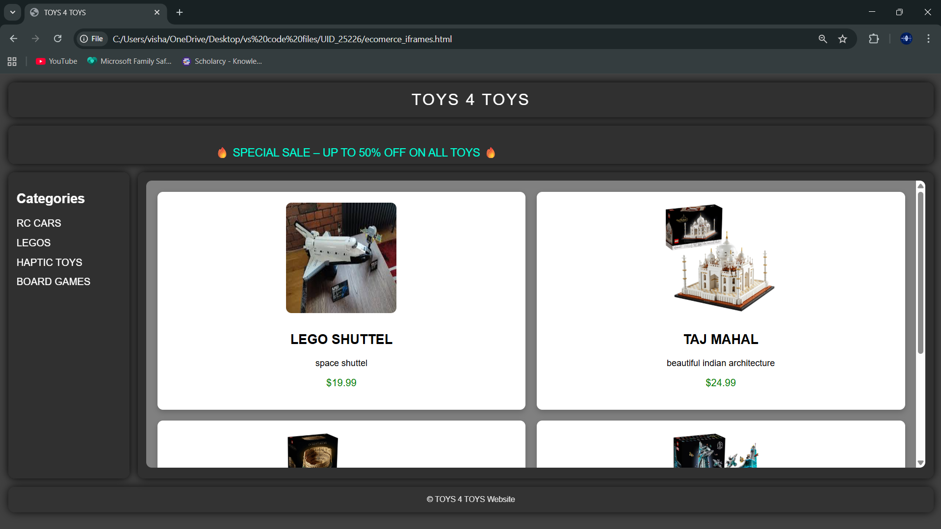
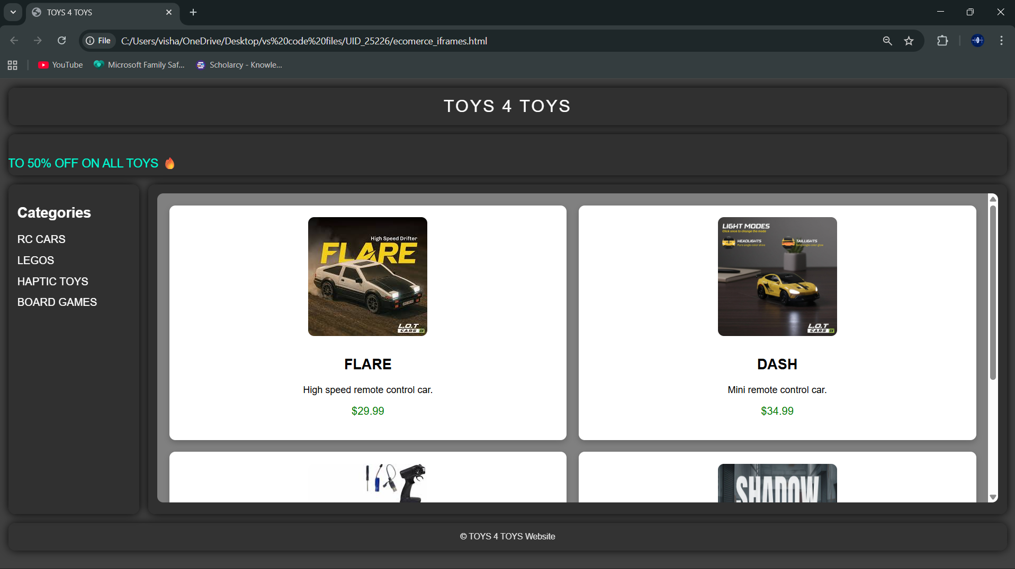
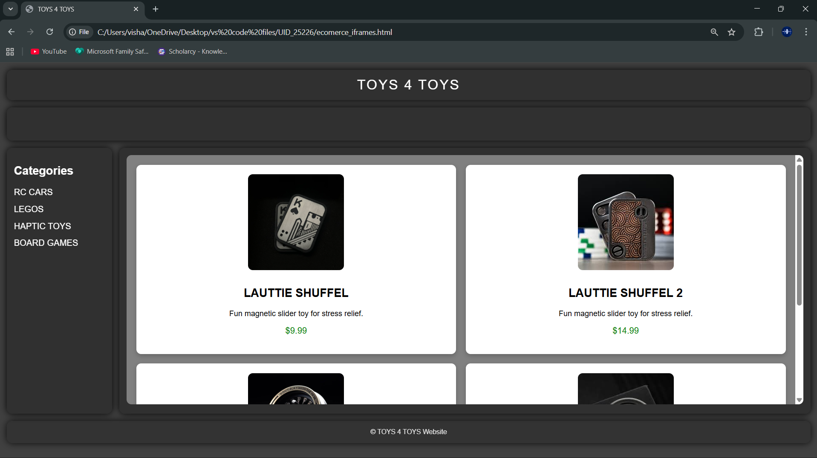
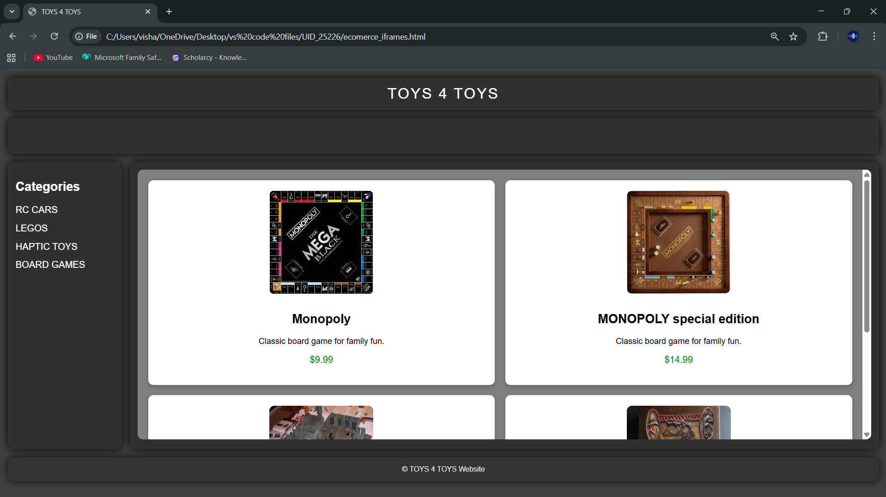
Explanation:
<DOCTYPE html> : the <!DOCTYPE html> element tells the web browser that this an HTML document
or this is the latest version of HTML
<html> : the <html> element is the root element of an HTML web page
<head> : the <head> element will contain meta data about the HTML web page
<title> : the <title> element specifies a title for the HTML Page
<body> : the <body> element contains all visible content all visible content like text , image , links ,
tables , etc
<h> : we used <h> element for heading
<p> : we used <p> element for the paragraph
<div>:we use <div> element for encapsulating the the divisions and easy to modify and
<button>: we use <button> element for button
<img>: we use <img> tag for displaying the image
<I frame>:we <iframe> tag to create link other webpages into it.
We used layout in this program and its attributes like grid-template-rows, grid-template-coloums, grid-template-area to define the items space for the grid layout by dividing page into separate sections and use div tag make into small separate blocks and we used I frames to link the sub webpages into main webpage we attribute target and name for easy understanding and reduce the code .

Week -7:
7.A) Aim: create a GitHub account and create a repository in it and push all the week 6 code files in it.
Procedure :
Step 1: browse for GitHub and enter it.
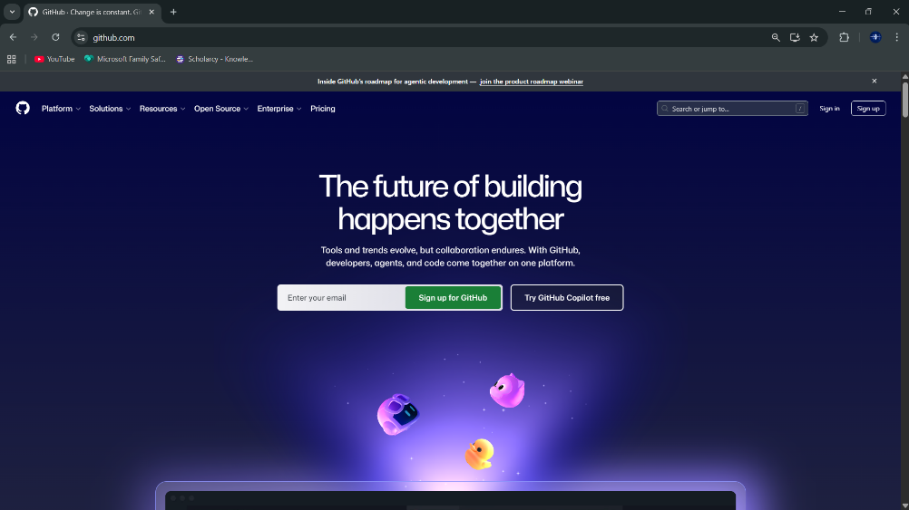
Step 2:login to GitHub account.
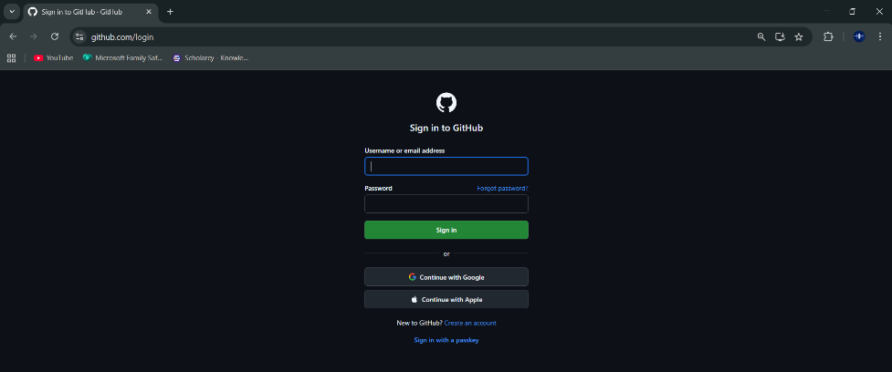
Step 3:create a repository after login by clicking new.
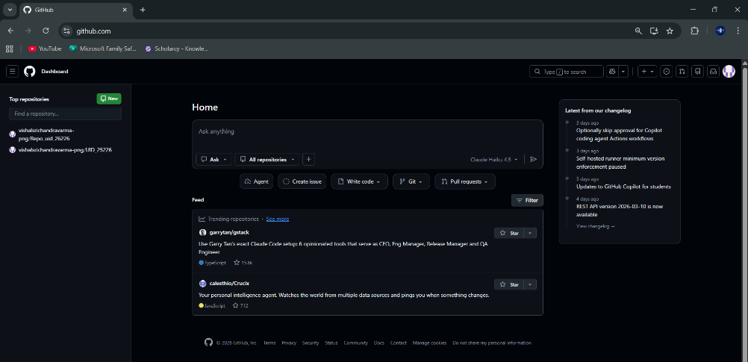
Step 4:specify the repository specifications.
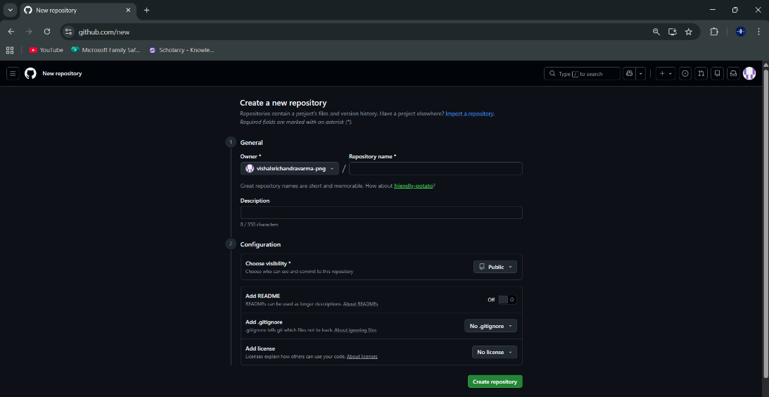
Step 5:download GitHub desktop and Lauch it .
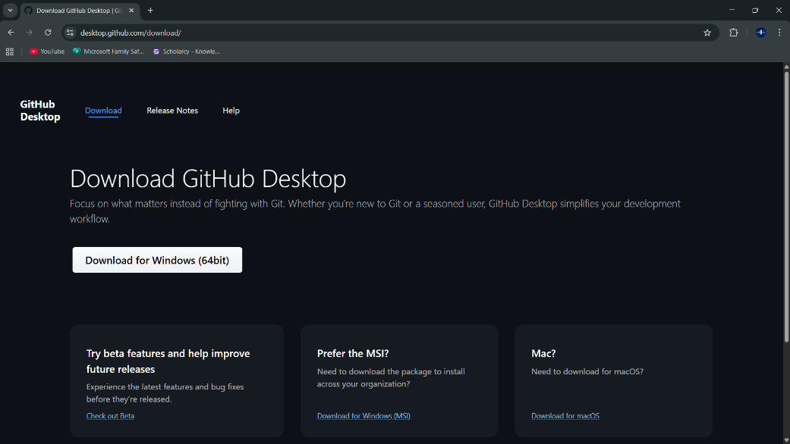
Step 6:add the repository to it .
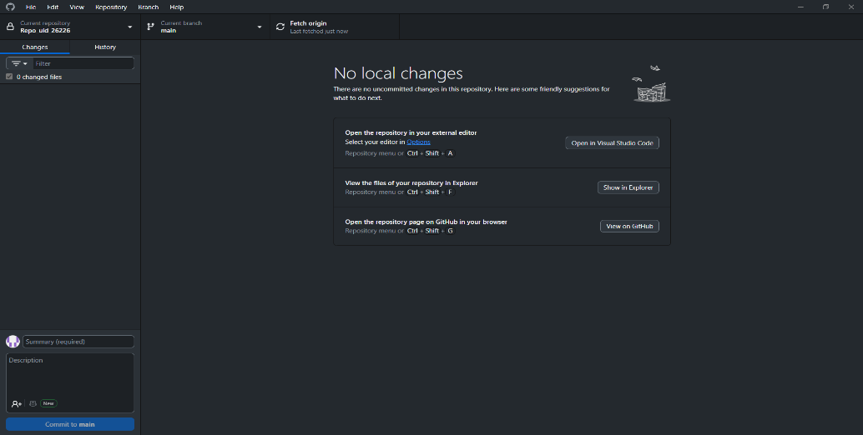
Step 7:add the vs code file to the GitHub desktop.
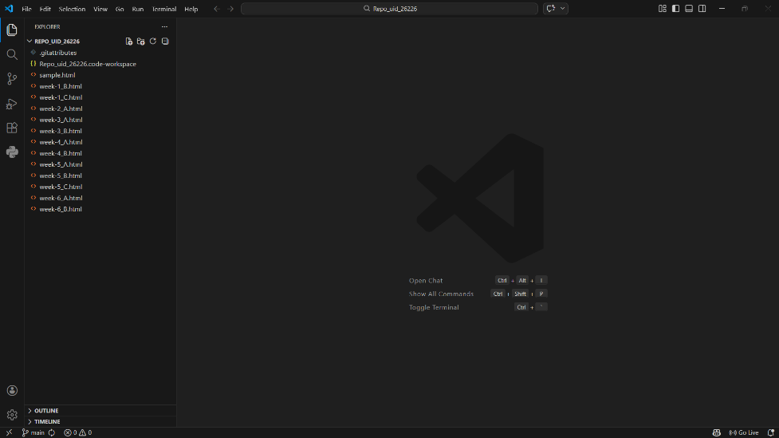
Step 8:add commit to it and the files to repository and sync the changes . it automatically
pushes the files .
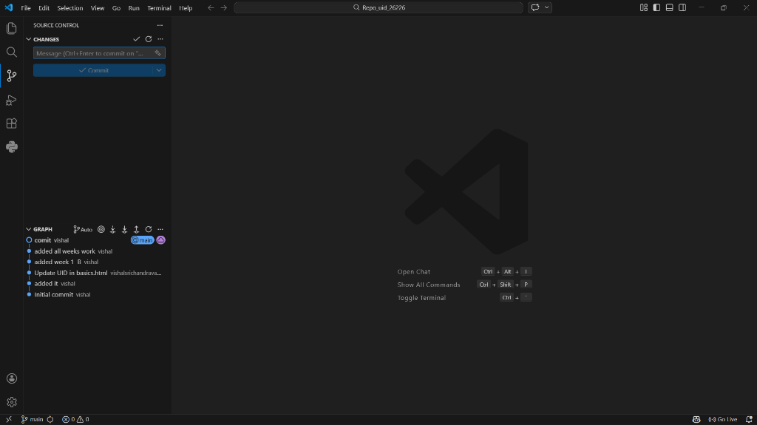
Step 9:now go to browser and check it . it will show all the new added files in the repository .
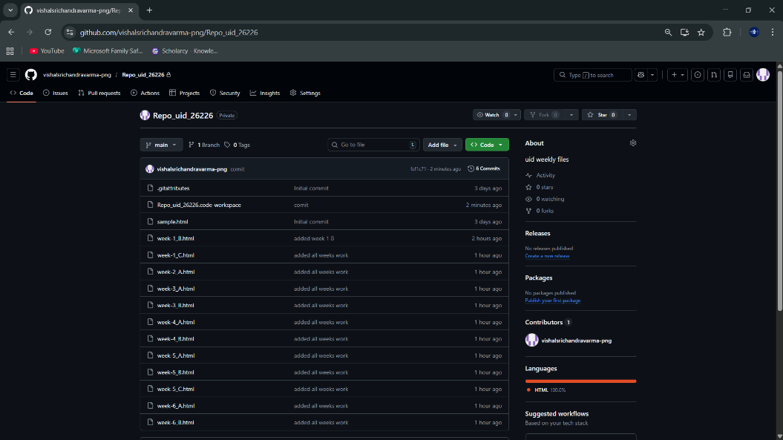
My repository link for the uid all week’s work:
https://github.com/vishalsrichandravarma-png/Repo_uid_26226.git
week 8:
8.A) Aim: create a web page that displays a square that continuously rotates 360 using css animation
Program :
AV.SC.U4CSE25226-UID
<!DOCTYPE html>
<html>
<head>
<title>Rotating Square</title>
<style>
body {
margin: 0;
height: 100vh;
display: flex;
flex-direction: column;
justify-content: flex-start;
align-items: center;
background-color: #2f3e46;
font-family: Arial, sans-serif;
padding-top: 50px;
}
.square {
width: 120px;
height: 120px;
background: #ffffffcc;
border-radius: 12px;
box-shadow: 0 8px 25px rgba(0, 0, 0, 0.2);
animation: rotate 3s linear infinite;
}
@keyframes rotate {
from {
transform: rotate(0deg);
}
to {
transform: rotate(360deg);
}
}
</style>
</head>
<body>
<h1 style=”color: #fff;”>Rotating Square</h1>
<div class=”square”></div>
</body>
</html>

Output:
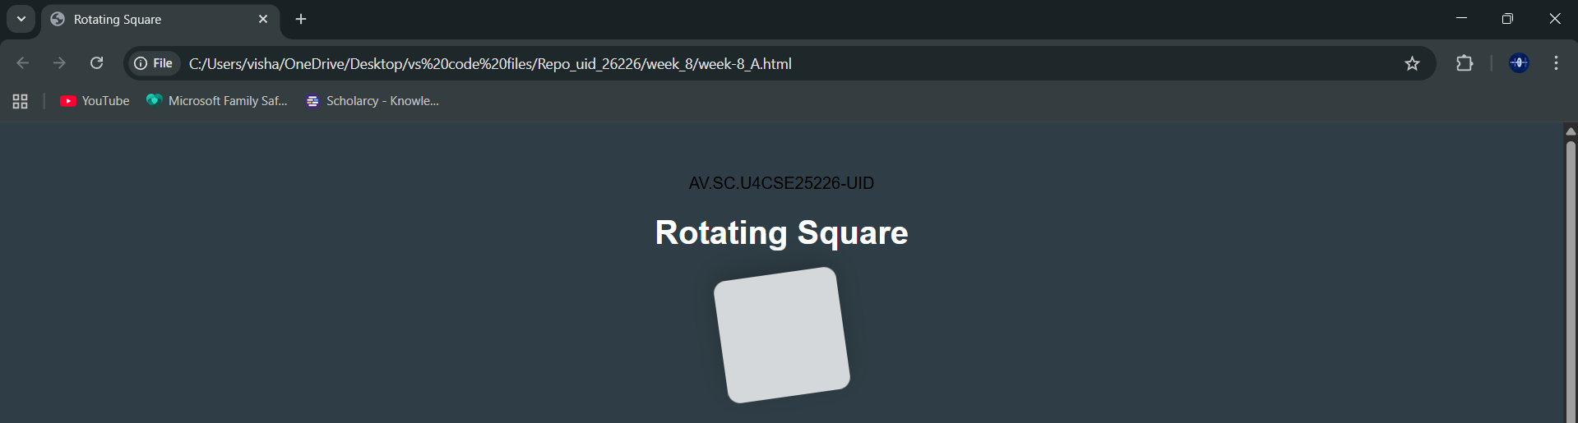
Explanation:
<DOCTYPE html> : the <!DOCTYPE html> element tells the web browser that this an HTML document
or this is the latest version of HTML
<html> : the <html> element is the root element of an HTML web page
<head> : the <head> element will contain meta data about the HTML web page
<title> : the <title> element specifies a title for the HTML Page
<body> : the <body> element contains all visible content all visible content like text , image , links ,
tables , etc
<h> : we used <h> element for heading
<div>:we use <div> element for encapsulating the the divisions and easy to modify and
@keyframes:we use @keyframes for animation from starting to end transformation.
We used animation shorthand property for these things to mention the animations preferences and use keyframes for mentioning the positions of the animation and used style attribute and some value properties for look and we used internal css in it .
8.B)Aim :create a ball that moves up and down continuously using css animation
Program :
AV.SC.U4CSE25226-UID
<!DOCTYPE html>
<html>
<head>
<title>Bouncing Ball</title>
<style>
body {
margin: 0;
height: 100vh;
display: flex;
flex-direction: column;
align-items: center;
justify-content: flex-start;
background: #2f3e46;
}
h1 {
margin-top: 20px;
color: #ffffff;
}
.ball {
width: 80px;
height: 80px;
background: #ffffff;
border-radius: 50%;
margin-top: 120px;
animation: bounce 1.5s ease-in-out infinite;
}
@keyframes bounce {
0% {
transform: ranslate(0);
}
50% {
transform: ranslate(-120px);
}
100% {
transform: ranslate(0);
}
}
</style>
</head>
<body>
<h1>Bouncing Ball</h1>
<div class=”ball”></div>
</body>
</html>
Output:
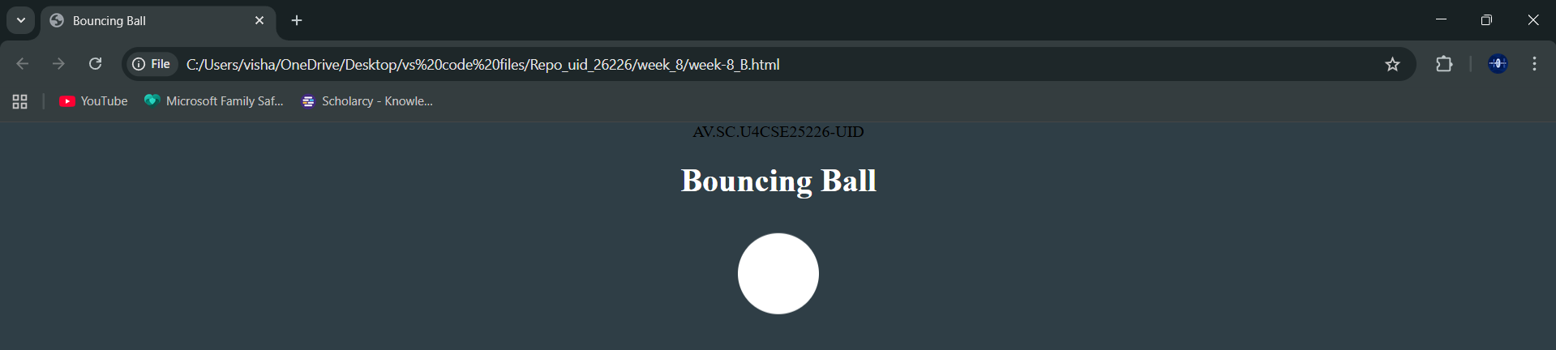
Explanation:
<DOCTYPE html> : the <!DOCTYPE html> element tells the web browser that this an HTML document
or this is the latest version of HTML
<html> : the <html> element is the root element of an HTML web page
<head> : the <head> element will contain meta data about the HTML web page
<title> : the <title> element specifies a title for the HTML Page
<body> : the <body> element contains all visible content all visible content like text , image , links ,
tables , etc
<h> : we used <h> element for heading
<div>:we use <div> element for encapsulating the the divisions and easy to modify and
@keyframes:we use @keyframes for animation from starting to end transformation.
We used animation shorthand property for these things to mention the animations preferences and use keyframes for mentioning the positions of the animation and used style attribute and some value properties for look and we used internal css in it .
8.C)Aim :create a circle that moves horizontally and rotates At the same time
Program:
AV.SC.U4CSE25226-UID
<!DOCTYPE html>
<html lang=”en”>
<head>
<title>Moving Rotating Circle</title>
<style>
body {
margin: 0;
height: 100vh;
display: flex;
flex-direction: column;
align-items: center;
justify-content: flex-start;
background: #2f3e46;
overflow: hidden;
}
h1 {
margin-top: 20px;
color: #ffffff;
}
.circle {
width: 80px;
height: 80px;
background: #ffffff;
border-radius: 50%;
margin-top: 120px;
animation: moveRotate 3s linear infinite;
}
@keyframes moveRotate {
0% {
transform: ranslate(-150px) rotate(0deg);
}
50% {
transform: ranslate(150px) rotate(180deg);
}
100% {
transform: ranslate(-150px) rotate(360deg);
}
}
</style>
</head>
<body>
<h1>Moving Rotating Circle</h1>

<div class=”circle”></div>
</body>
</html>

Output:
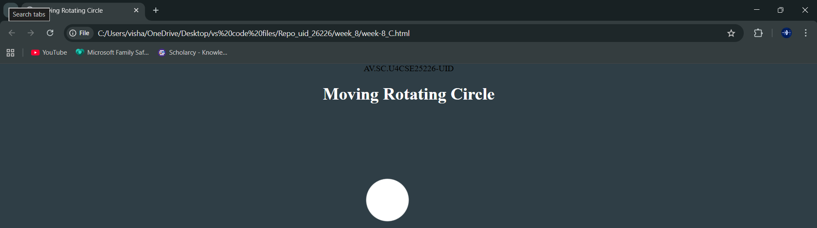
Explanation:
<DOCTYPE html> : the <!DOCTYPE html> element tells the web browser that this an HTML document
or this is the latest version of HTML
<html> : the <html> element is the root element of an HTML web page
<head> : the <head> element will contain meta data about the HTML web page
<title> : the <title> element specifies a title for the HTML Page
<body> : the <body> element contains all visible content all visible content like text , image , links ,
tables , etc
<h> : we used <h> element for heading
<div>:we use <div> element for encapsulating the divisions and easy to modify and
@keyframes:we use @keyframes for animation from starting to end transformation.
We used animation shorthand property for these things to mention the animations preferences and use keyframes for mentioning the positions of the animation and used style attribute and some value properties for look and we used internal css in it .

Week 9:
9.A)Aim: Week 9:Create a webpage using html,css,js based on the give conditions, create a button for each program , based on the button, clicked the corresponding program has to be executed and should display the logics for each button includes finding an even or odd number , prime or not , factorial of a number , Armstrong or not use appropriate design to display the output.
Program:
<!DOCTYPE html>
<html>
<head>
<title>Logic Programs</title>
<style>
body {
margin: 0;
font-family: Arial, sans-serif;
background: #1a1a2e;
display: flex;
justify-content: center;
align-items: center;
min-height: 100vh;
}
.container {
background: white;
border-radius: 12px;
box-shadow: 0 4px 20px rgba(0,0,0,0.3);
padding: 40px;
width: 380px;
text-align: center;
}
h2 {
margin-bottom: 20px;
color: #333;
}
input {
width: 100%;
padding: 10px;
font-size: 16px;
border: 2px solid #ccc;
border-radius: 8px;
margin-bottom: 20px;
box-sizing: border-box;
text-align: center;
}
input:focus {
outline: none;
border-color: #4a90e2;
}
.buttons {
display: grid;
grid-template-columns: 1fr 1fr;
gap: 12px;
margin-bottom: 24px;
}
button {
padding: 12px;
font-size: 15px;
border: none;
border-radius: 8px;
cursor: pointer;
color: white;
font-weight: bold;
background: #4a90e2;
transition: opacity 0.2s;
}
button:hover { opacity: 0.85; }
.output {
background: #f0f4f8;

padding: 20px;
border-radius: 8px;
min-height: 60px;
color: #333;
font-size: 16px;
}
</style>
</head>
<body>

<div class="container">
<h2>Logic Programs</h2>
<input type="number" id="numInput" placeholder="Enter a number" />
<div class="buttons">
<button onclick="checkEvenOdd()">Even / Odd</button>
<button onclick="checkPrime()">Prime / Not</button>
<button onclick="calcFactorial()">Factorial</button>
<button onclick="checkArmstrong()">Armstrong</button>
</div>
<div class="output" id="output">Result will appear here</div>
</div>
<script>
function getInput() {
const val = document.getElementById('numInput').value.trim();
if (val === '' || isNaN(val)) {
document.getElementById('output').textContent = 'Please enter a valid number.';
return null;
}
return parseInt(val);
}
function setOutput(text) {
document.getElementById('output').textContent = text;
}
function checkEvenOdd() {
const n = getInput();
if (n === null) return;
setOutput(n + ' is ' + (n % 2 === 0 ? 'Even' : 'Odd'));
}
function checkPrime() {
const n = getInput();
if (n === null) return;
if (n < 2) { setOutput(n + ' is Not Prime'); return; }
for (let i = 2; i <= Math.sqrt(n); i++) {
if (n % i === 0) { setOutput(n + ' is Not Prime'); return; }
}
setOutput(n + ' is Prime');
}
function calcFactorial() {
const n = getInput();
if (n === null) return;
if (n < 0) { setOutput('Factorial not defined for negative numbers'); return; }
let result = 1;
for (let i = 2; i <= n; i++) result *= i;
setOutput(n + '! = ' + result);
}
function checkArmstrong() {
const n = getInput();
if (n === null) return;
const digits = String(n).split('');
const power = digits.length;
const sum = digits.reduce((acc, d) => acc + Math.pow(Number(d), power), 0);
setOutput(n + (sum === n ? ' is an Armstrong number' : ' is Not an Armstrong number'));
}
</script>
</body>
</html>
Output:

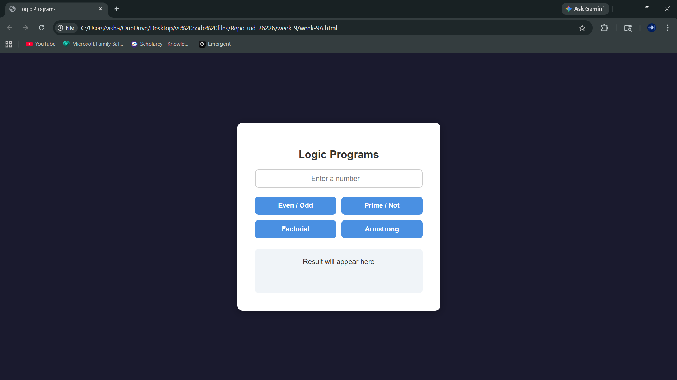
Explanation:
<DOCTYPE html> : the <!DOCTYPE html> element tells the web browser that this an HTML document
or this is the latest version of HTML
<html> : the <html> element is the root element of an HTML web page
<head> : the <head> element will contain meta data about the HTML web page
<title> : the <title> element specifies a title for the HTML Page
<body> : the <body> element contains all visible content all visible content like text , image , links ,
tables , etc
<h> : we used <h> element for heading
<div>:we use <div> element for encapsulating the divisions and easy to modify
<style> : the <style> element is used to write CSS (designing part) it controls colors, layout, spacing, etc
body : the body selector is used to design the whole page here it sets background color and centers the
content
.container : used to design the main box (card)gives white background, padding, shadow and rounded
corners
input : used to design the input box width, padding, border and text alignment are set
button : used to design buttons gives color, size, border and hover effect
.output : used to design output box where result will be displayed
<input> : the <input> element is used to take user input type="number" allows only numbers id is used to
access it in JavaScript
<div class="buttons"> : groups all buttons together
<button> : used to perform actions when clicked onclick calls JavaScript functions
<div id="output"> : used to display result initially shows "Result will appear here"
<script> : the <script> element is used to write JavaScript code it adds logic and functionality to the
webpage
getElementById() : used to access HTML elements using id
.value : used to get value from input box
.textContent : used to display or change text inside an element
function : used to define a block of code that performs a task
checkEvenOdd() : checks whether number is even or odd uses n % 2
checkPrime() : checks whether number is prime or not uses loop and division logic
calcFactorial() : calculates factorial of a number multiplies numbers from 1 to n
checkArmstrong() : checks Armstrong number sum of digits power equals number
Math.sqrt() : used to find square root (used in prime logic)
parseInt() : converts string to integer
isNaN() : checks if value is not a number

Week-10 :
10.A)Aim: write JavaScript conditional statement to find the sign of product of three numbers using functions .Display an alert box with specified sign .write a java script conditional statements to sort 3 numbers using functions display an alert box to show the result.write a java script conditional statement to find largest of find largest of five numbers using function and onclick event .display an alert box to show the result .write a java script for loop that will iterate from 0 to 15. For each iteration ,it will check if the current number odd or even , and display a message on screen .write a java script program to read 6 subjects marks from the student then computes the average marks of students then , this average is used to determine the corresponding grade.
Program :
<!DOCTYPE html>
<html>
<head>
<title>Logic Programs</title>
<style>
body {
font-family: Arial;
display: flex;
height: 100vh;
}
.left {
width: 30%;
background: beige;
padding: 20px;
border-right: 3px solid #ccc;
}
.right {
width: 70%;
background: #f5f5dc;
padding: 20px;
}
input {
width: 95%;
padding: 10px;
margin-bottom: 10px;
}
button {
width: 100%;
padding: 10px;
margin-bottom: 10px;
background: #d2b48c;
border: none;
cursor: pointer;
}
#output {
background: #fff8dc;
padding: 20px;
min-height: 200px;
white-space: pre-line;
}
</style>
</head>
<body>
<div class="left">
<h3>Enter Input</h3>
<input type="text" id="numbers" placeholder="Click a button to see input format">
<button onclick="signProduct()">Sign of Product</button>
<button onclick="sortNumbers()">Sort Numbers</button>
<button onclick="largestNumber()">Largest Number</button>
<button onclick="oddEvenLoop()">Odd / Even 0-15</button>
<button onclick="studentGrade()">Student Grade</button>
</div>
<div class="right">
<h3>Output</h3>
<div id="output">Result will appear here</div>
</div>
<script>
function getNumbers() {
let input = document.getElementById("numbers").value;
return input.split(",").map(Number);
}
function signProduct() {
let input = document.getElementById("numbers").value;
if (input === "") {
document.getElementById("output").textContent =
"Enter 3 numbers like: 0,-1,4";
return;
}
let nums = getNumbers();
let negative = 0;
for (let n of nums) {
if (n < 0) negative++;
}
let result = (negative % 2 == 0) ? "+1" : "-1";
alert(result);
document.getElementById("output").textContent = "Sign: " + result;
}
function sortNumbers() {
let input = document.getElementById("numbers").value;
if (input === "") {
document.getElementById("output").textContent =
"Enter 3 numbers like: 0,-1,4";
return;
}
let nums = getNumbers();
nums.sort((a, b) => b - a);
alert(nums.join(", "));
document.getElementById("output").textContent =
"Sorted: " + nums.join(", ");
}
function largestNumber() {
let input = document.getElementById("numbers").value;
if (input === "") {
document.getElementById("output").textContent =
"Enter 5 numbers like: -5,-2,-6,0,-1";
return;
}
let nums = getNumbers();
let max = nums[0];
for (let n of nums) {
if (n > max) max = n;
}
alert("Largest: " + max);
document.getElementById("output").textContent =
"Largest: " + max;
}
function oddEvenLoop() {
let input = document.getElementById("numbers").value;
if (input === "") {
document.getElementById("output").textContent =
"Enter a number like: 15 (to check from 0 to that number)";
return;
}
let n = Number(input);
let result = "";
for (let i = 0; i <= n; i++) {
if (i % 2 == 0)
result += i + " is Even\n";
else
result += i + " is Odd\n";
}

document.getElementById("output").textContent = result;
}
function studentGrade() {
let input = document.getElementById("numbers").value;
if (input === "") {
document.getElementById("output").textContent =
"Enter 6 subject marks like: 70,80,90,60,75,85";
return;
}
let nums = getNumbers();
let sum = 0;
for (let n of nums) sum += n;
let avg = sum / nums.length;
let grade;
if (avg >= 90) grade = "A";
else if (avg >= 75) grade = "B";
else if (avg >= 60) grade = "C";
else grade = "D";
alert("Average: " + avg + " Grade: " + grade);
document.getElementById("output").textContent =
"Average: " + avg + " | Grade: " + grade;
}
</script>
</body>
</html>
Output :
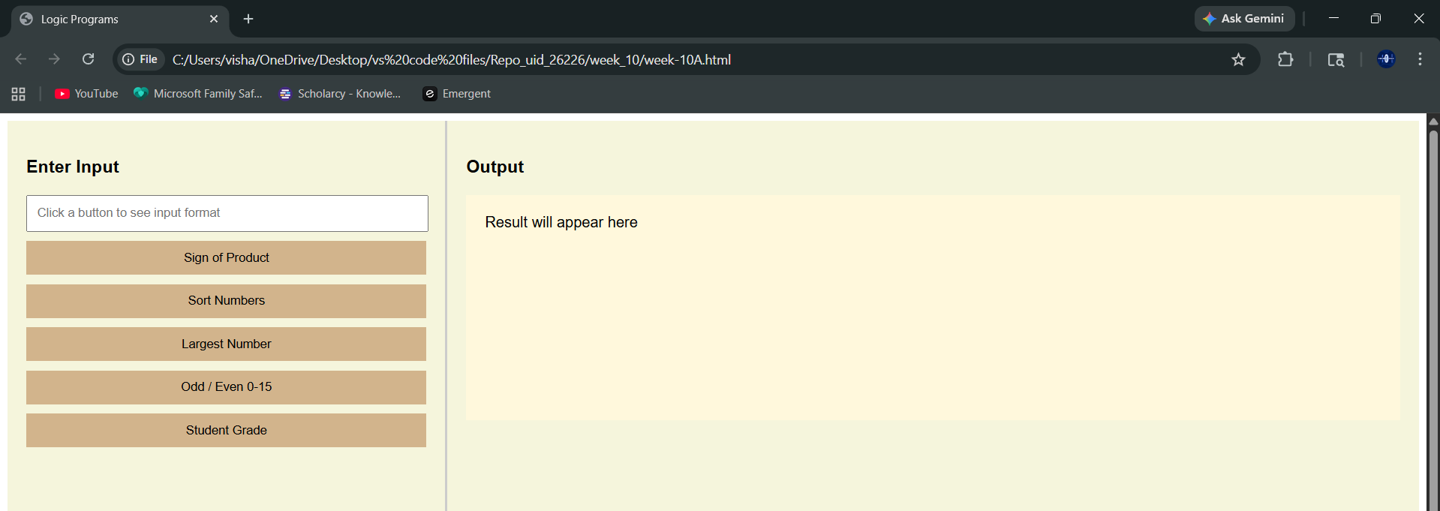
Explanation :
<!DOCTYPE html> : the <!DOCTYPE html> element tells the browser that this is an HTML5 document
<html> : the <html> element is the root element of the web page all elements are written inside this
<head> : the <head> element contains meta information like title and styles
<title> : the <title> element specifies the name of the web page it appears on the browser tab
<style> : the <style> element is used to write CSS for designing the page
body : the body selector is used to style the whole page here flex is used to divide page into two sections
.left : this class is used for left side panel contains input box and buttons
.right : this class is used for right side panel used to display output
input : the <input> element is used to take user input here type="text" is used to enter numbers like 1,2,3
button : the <button> element is used to perform actions onclick is used to call JavaScript functions
<div> : the <div> element is used to group elements helps in layout design
#output : this is an id used to display result .textContent is used to change its text
<script> : the <script> element is used to write JavaScript code
function : used to define a block of code that performs a task
getElementById() : used to access HTML elements using id
.value : used to get value from input box
.split(",") : used to convert input string into array using comma
.map(Number) : converts string values into numbers
for loop : used to repeat code multiple times
if condition : used to check conditions
alert() : used to display popup message
sort() : used to sort numbers in array
max logic : used to find largest number using loop
oddEvenLoop() : checks numbers from 0 to given input tells whether each number is even or odd
studentGrade() : calculates average of marks assigns grade based on conditions
.textContent : used to display output on the web page
Week -11
11.A)Aim: A website requires users to enter a username. The system should display a message while typing if the username is less than 5 characters.
Program :
<html>
<head>
<title>Username Check</title>
<style>
body {
margin:0;
font-family: Arial;
background: linear-gradient(120deg,#2980b9,#6dd5fa);
display:flex;
justify-content:center;
align-items:center;
height:100vh;
}
.card {
background:white;
padding:30px;
border-radius:12px;
width:300px;
box-shadow:0 10px 25px rgba(0,0,0,0.2);
}
input { width:100%; padding:10px; margin-top:10px; }
</style>
</head>
<body>
<div class="card">
<h2>Username</h2>
<input type="text" id="username" placeholder="Enter username" onkeyup="checkUsername()">
<p id="msg"></p>
</div>
<script>
function checkUsername() {
let val=document.getElementById("username").value;
let msg=document.getElementById("msg");
if(val.length<5){ msg.innerText="Minimum 5 characters required"; msg.style.color="red"; }
else{ msg.innerText="Valid username"; msg.style.color="green"; }
}
</script>
</body>
</html>

Output :
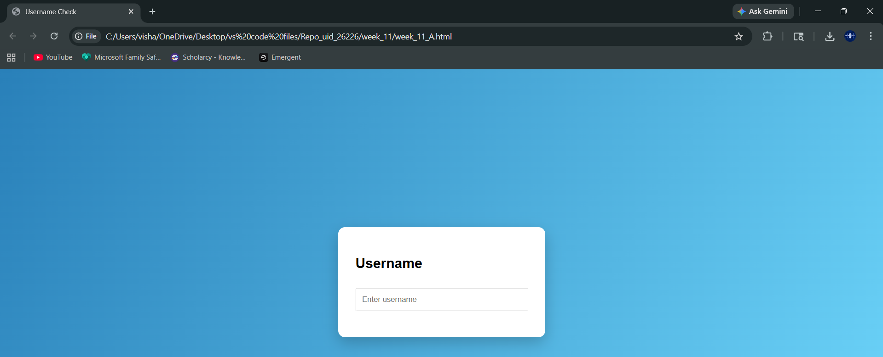
Explanation :
<!DOCTYPE html> : the <!DOCTYPE html> element tells the browser that this is an HTML5 document
<html> : the <html> element is the root element of the web page all elements are written inside this
<head> : the <head> element contains meta information like title and styles
<title> : the <title> element specifies the name of the web page it appears on the browser tab
<style> : the <style> element is used to write CSS for designing the page
body : the body selector is used to style the whole page here flex is used to center the card layout
.card : this class is used to create a box container with padding shadow and rounded corners
input : the <input> element is used to take user input for username
<p> : the <p> element is used to display validation message
<script> : the <script> element is used to write JavaScript code
function : used to define a block of code that performs username validation
getElementById() : used to access username input and message element
.value : used to get value from input box
length : used to check number of characters entered
if condition : used to check if username is less than 5 characters
innerText : used to display message on screen
style.color : used to change text color based on validation
11.B)Aim : A registration form should validate email format before submission. If invalid, the form should not be submitted
Program:
<html>
<head>
<title>Email Validation</title>
<style>
body{margin:0;font-family:Arial;background:linear-gradient(120deg,#ff6a00,#ee0979);display:flex;justify-content:center;align-items:center;height:100vh;}
.card{background:white;padding:30px;border-radius:12px;width:320px;box-shadow:0 10px 25px rgba(0,0,0,0.2);}
input,button{width:100%;padding:10px;margin-top:10px;}
button{background:#ee0979;color:white;border:none;cursor:pointer;}
</style>
</head>
<body>
<div class="card">
<h2>Email Check</h2>
<form onsubmit="return validateEmail()">
<input type="text" id="email" placeholder="Enter Email">
<button type="submit">Submit</button>
</form>
</div>
<script>
function validateEmail(){
let email=document.getElementById("email").value;
let pattern=/^[^ ]+@[^ ]+\.[a-z]{2,3}$/;
if(pattern.test(email)){
alert("Email is valid");
return true;
}else{
alert("Invalid Email");
return false;
}
}
</script>
</body>
</html>

Output :
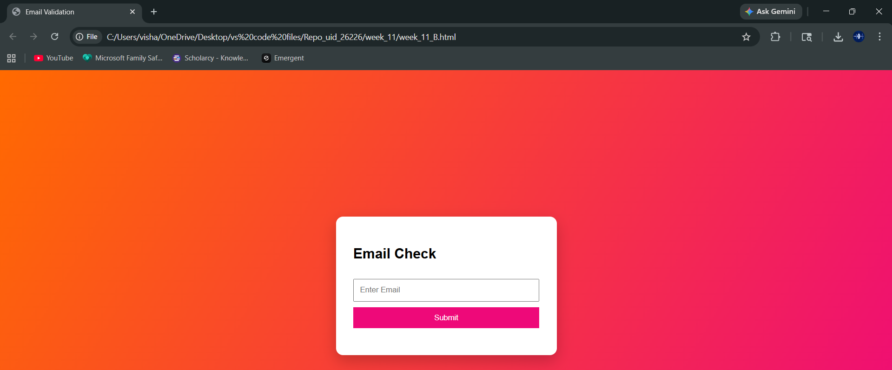
Explanation :
<!DOCTYPE html> : the <!DOCTYPE html> element tells the browser that this is an HTML5 document
<html> : the <html> element is the root element of the web page
<head> : contains title and styles
<title> : displays page name on browser tab
<style> : used to design the page with gradient background and card layout
form : the <form> element is used to collect user input
input : used to take email input from user
button : used to submit the form
onsubmit : used to call JavaScript function when form is submitted
<script> : used to write JavaScript validation logic
function : defines email validation logic
getElementById() : used to access email input
.value : gets the email value entered by user
pattern : regular expression used to check valid email format
test() : checks if email matches pattern
if condition : checks whether email is valid or not
alert() : used to display popup message for valid or invalid email
return false : prevents form submission if invalid
return true : allows form submission if valid
11.C)Aim: A system should check password strength while typing and display whether it is weak or strong.
Program :
<html>
<head>
<title>Password Strength</title>
<style>
body{margin:0;font-family:Arial;background:linear-gradient(120deg,#00b09b,#96c93d);display:flex;justify-content:center;align-items:center;height:100vh;}
.card{background:white;padding:30px;border-radius:12px;width:350px;box-shadow:0 10px 25px rgba(0,0,0,0.2);}
input{width:100%;padding:10px;margin-top:10px;}
</style>
</head>
<body>
<div class="card">
<h2>Password Strength</h2>
<p><b>Rules:</b><br>• At least 6 characters<br>• One uppercase letter<br>• One special symbol</p>
<input type="password" id="pass" onkeyup="checkStrength()">
<p id="msg"></p>
</div>
<script>
function checkStrength(){
let pass=document.getElementById("pass").value;
let msg=document.getElementById("msg");
let strong=/^(?=.*[A-Z])(?=.*[!@#$%^&*]).{6,}$/;
if(strong.test(pass)){
msg.innerText="Strong Password";
msg.style.color="green";
}else{
msg.innerText="Weak Password";
msg.style.color="red";
}
}
</script>
</body>
</html>
Output:
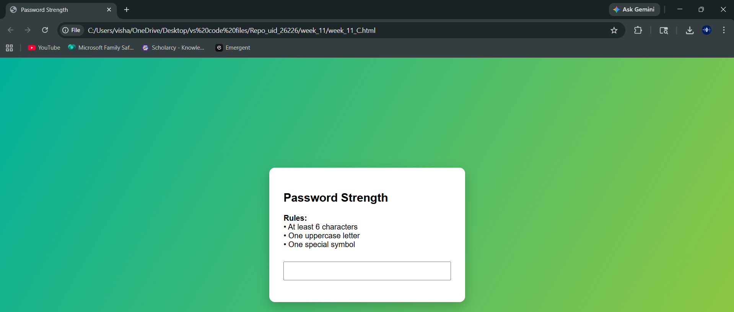
Explanation:
<!DOCTYPE html> : defines HTML5 document
<html> : root element of webpage
<head> : contains title and style
<title> : shows page title
<style> : used for page design and layout styling
body : used to center the card with gradient background
.card : used to create container box
<p> : used to display password rules
input : used to enter password
<script> : contains JavaScript logic
function : defines password checking logic
getElementById() : used to access password input and message
.value : gets password entered by user
pattern : regular expression used to check password strength
(?=.*[A-Z]) : ensures at least one uppercase letter
(?=.*[!@#$%^&*]) : ensures at least one special symbol
.{6,} : ensures minimum 6 characters
test() : checks if password matches pattern
if condition : checks strong or weak password
innerText : displays result message
style.color : changes text color based on strength
11.D)Aim : A form should validate a mobile number when the user leaves the input field. The number must be exactly 10 digits
Program :
<!DOCTYPE html>
<html>
<head>
<title>Mobile Validation</title>
<style>
body{margin:0;font-family:Arial;background:linear-gradient(120deg,#fc466b,#3f5efb);display:flex;justify-content:center;align-items:center;height:100vh;}
.card{background:white;padding:30px;border-radius:12px;width:320px;box-shadow:0 10px 25px rgba(0,0,0,0.2);}
input{width:100%;padding:10px;margin-top:10px;}
</style>
</head>
<body>
<div class="card">
<h2>Mobile & Password</h2>
<input type="text" id="mobile" placeholder="Enter Mobile" onblur="validateMobile()">
<input type="password" id="pass" placeholder="Enter Password" onkeyup="checkPass()">
<p id="msg"></p>
</div>
<script>
function validateMobile(){
let num=document.getElementById("mobile").value;
let msg=document.getElementById("msg");
let pattern=/^[0-9]{10}$/;
if(pattern.test(num)) msg.innerText="Valid mobile";
else msg.innerText="Invalid mobile";
}
function checkPass(){
let pass=document.getElementById("pass").value;
let strong=/^(?=.*[A-Z])(?=.*[!@#$%^&*]).{6,}$/;
let msg=document.getElementById("msg");
if(strong.test(pass)) msg.innerText="Strong Password";
else msg.innerText="Weak Password";
}
</script>
</body>
</html>

Output :
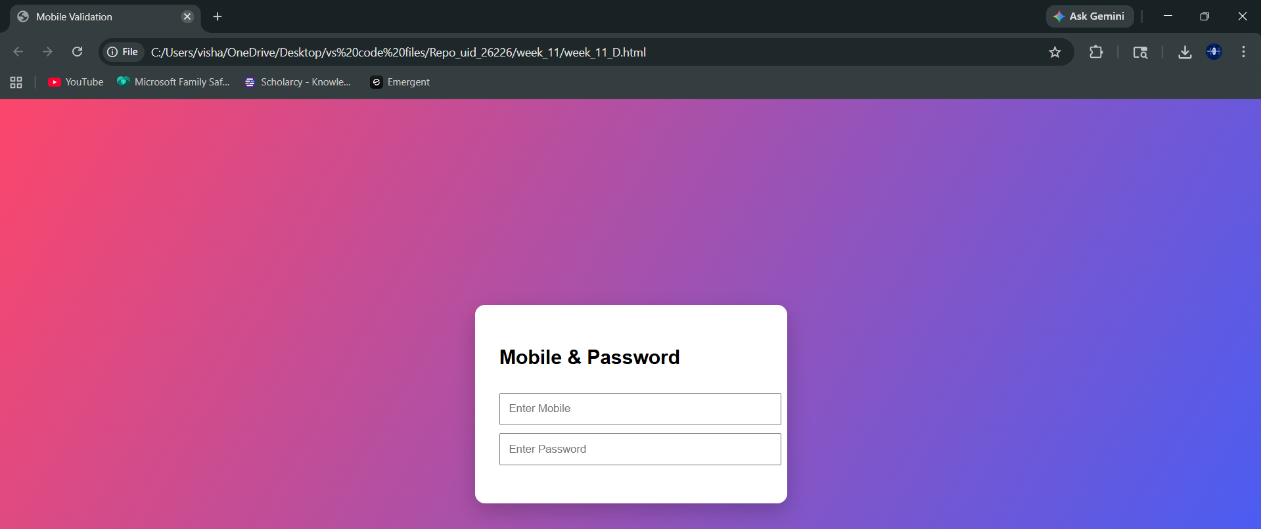
Explanation :
<!DOCTYPE html> : defines HTML5 document
<html> : root element of page
<head> : contains title and styles
<title> : sets page title
<style> : used for UI design and layout
body : centers the content using flexbox
.card : used as container box
input : used to take mobile number and password input
onblur : triggers validation when user leaves mobile input field
onkeyup : triggers password validation while typing
<script> : contains JavaScript code
function : defines validation logic
getElementById() : used to access input fields and message
.value : gets input values
pattern : regular expression for mobile validation
^[0-9]{10}$ : ensures exactly 10 digits
test() : checks if mobile number is valid
if condition : checks valid or invalid mobile
password pattern : same as strong password rule
innerText : displays result message
11.E)Aim: 5. Design an HTML page, such that the registration form must validate:
Name (not empty)
Email (valid format)
Password (minimum 6 characters)
Program :
<html>
<head>
<title>Register</title>
<style>
body{margin:0;font-family:Arial;background:linear-gradient(120deg,#141e30,#243b55);display:flex;justify-content:center;align-items:center;height:100vh;color:white;}
.card{background:white;color:black;padding:30px;border-radius:12px;width:350px;box-shadow:0 10px 25px rgba(0,0,0,0.3);}
input,button{width:100%;padding:10px;margin-top:10px;}
button{background:#243b55;color:white;border:none;cursor:pointer;}
</style>
</head>
<body>
<div class="card">
<h2>Registration Form</h2>
<form onsubmit="return validateForm()">
<input type="text" id="name" placeholder="Name">
<input type="text" id="email" placeholder="Email">
<input type="password" id="pass" placeholder="Password">
<button type="submit">Register</button>
<p id="msg"></p>
</form>
</div>
<script>
function validateForm(){
let name=document.getElementById("name").value;
let email=document.getElementById("email").value;
let pass=document.getElementById("pass").value;
let msg=document.getElementById("msg");
let emailPattern=/^[^ ]+@[^ ]+\.[a-z]{2,3}$/;
let strong=/^(?=.*[A-Z])(?=.*[!@#$%^&*]).{6,}$/;

if(name===""){ msg.innerText="Name required"; return false; }
if(!emailPattern.test(email)){ msg.innerText="Invalid email"; return false; }
if(!strong.test(pass)){ msg.innerText="Weak password"; return false; }
alert("Registration Successful");
return true;
}
</script>
</body>
</html>

Output :
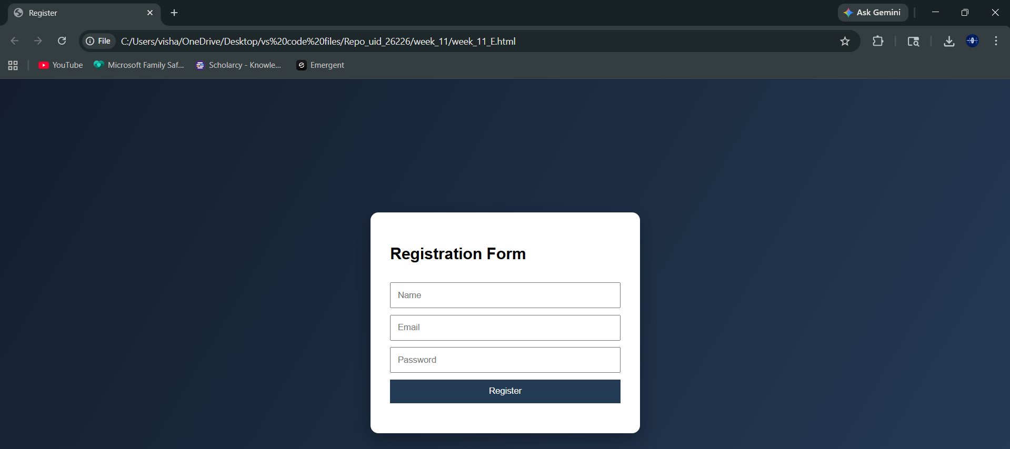
Explanation :
<!DOCTYPE html> : defines HTML5 document
<html> : root element of webpage
<head> : contains title and style
<title> : sets name of webpage
<style> : used to design form layout and appearance
body : centers form with gradient background
.card : used to create form container
form : used to collect user data
input : used to take name email and password
button : used to submit form
onsubmit : triggers validation before submission
<script> : contains JavaScript validation logic
function : defines form validation process
getElementById() : used to access form fields
.value : gets input values
emailPattern : checks valid email format
strong pattern : checks password strength
if condition : checks name not empty
if condition : checks email format
if condition : checks password rules
alert() : shows success message when all validations pass
return false : prevents submission if invalid
return true : allows submission if valid
innerText : displays error messages
Week-12
12). Aim : To show the steps involved in installing and using Electron.
Procedure :
Step – 1 : Install node js from the website “Node.js”.
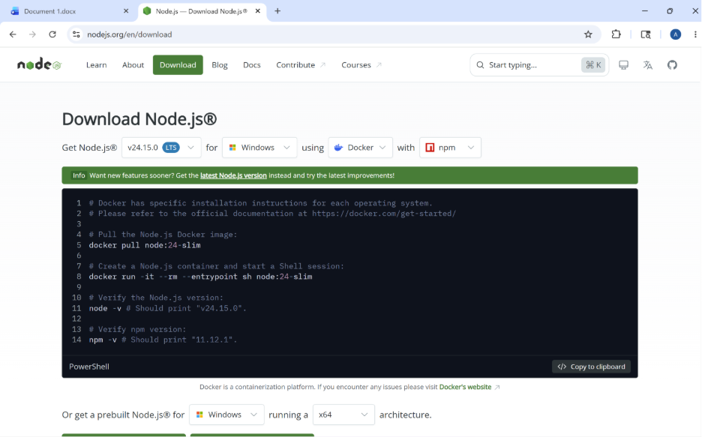
Step – 2 : Create folder with your liked name on desktop and open that folder in V.S. code .Now open terminal in that folder and type this command : “ npm init –y ”, on which will be installed package named “ package.json ” . Now , another command :“ npm install electron --save-dev", on which you will get “ package-lock.json ” and “node-modules”, this npm install electron –save-dev will install electron to the package.
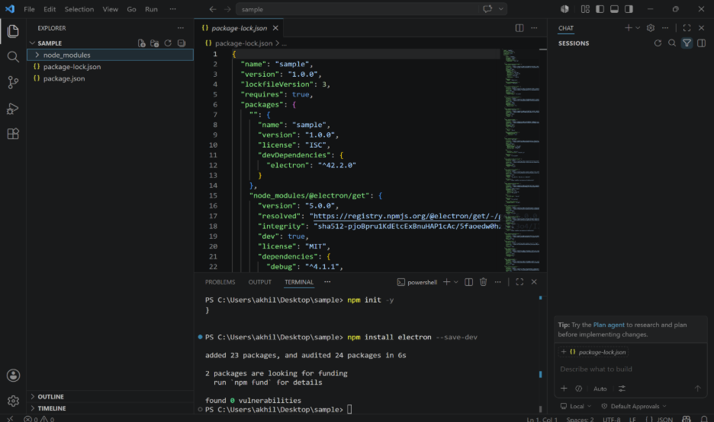
Step-3 : Now let us understand about this with an example of creating a mini calculator .Write the required codes for this project to be done in the folder after doing those above discussed steps.
index.html code :
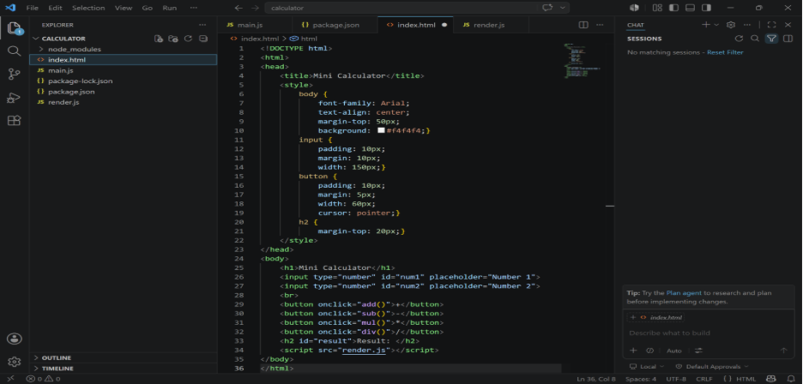
main.js code :
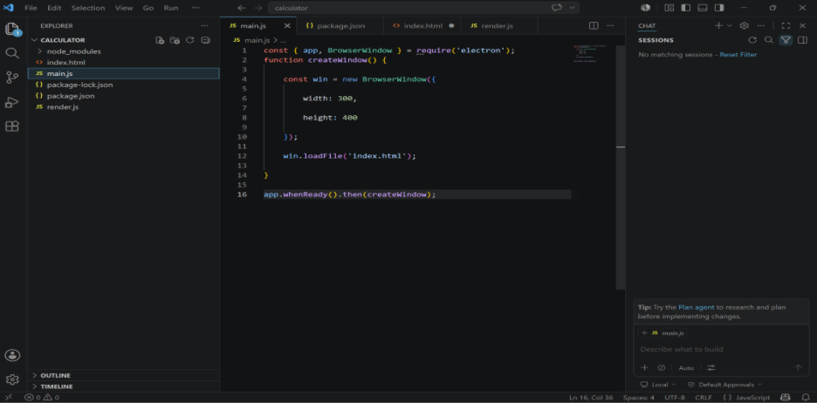
renderer.js code :
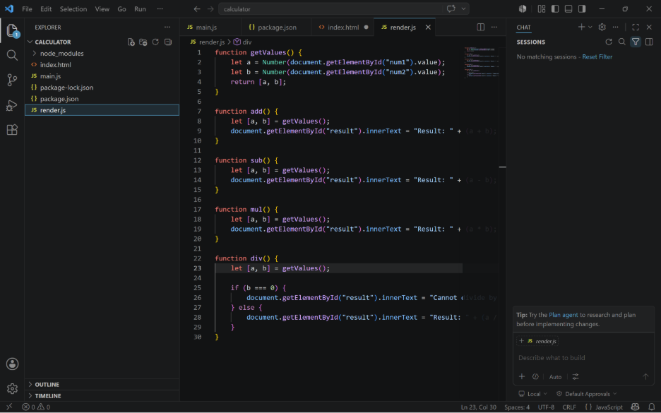
Step-4 : Now in package.json , change the ‘main’ value as ‘main.js’ and ‘start’ one as ‘electron .’ as shown.
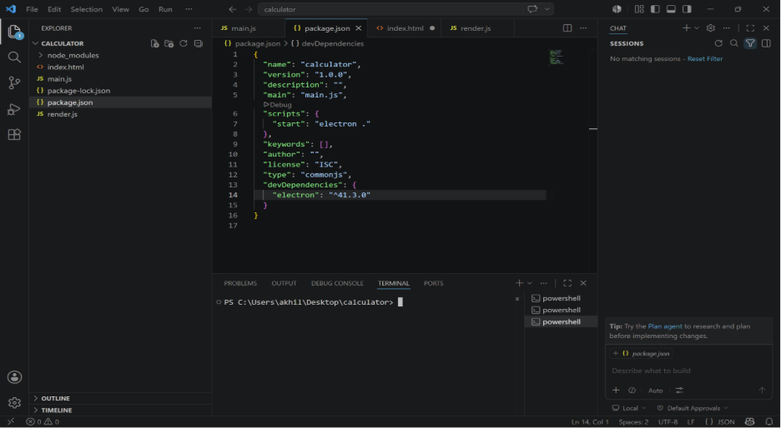
Step-5 : You are all done .Only thing left is to give “npm start” command in terminal for output.the command terminal should belong to the folder in which above steps are done
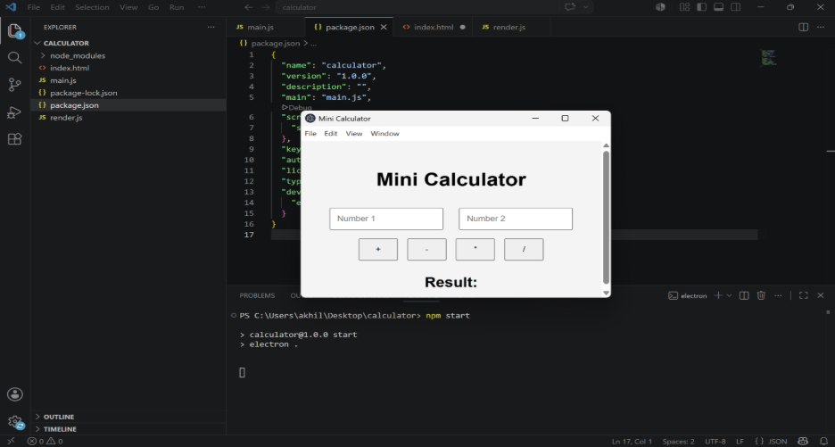
That is the output after giving the final command .

